Chapter 7
Consumers, Producers, and the Efficiency of Markets
Multiple Choice
1. Welfare economics is the study of
a. the well-being of less fortunate people.
b. welfare programs in the United States.
c. the effect of income redistribution on work effort.
d. how the allocation of resources affects economic well-being.
ANS: D PTS: 1 DIF: 1 REF: 7-0
TOP: Economic welfare MSC: Definitional
2. The study of how the allocation of resources affects economic well-being is called
a. consumer economics.
b. macroeconomics.
c. willingness-to-pay economics.
d. welfare economics.
ANS: D PTS: 1 DIF: 1 REF: 7-0
TOP: Economic welfare MSC: Definitional
3. Welfare economics is the study of
a. how the allocation of resources affects economic well-being.
b. how technology is best put to use in the production of goods and services.
c. government welfare programs for needy people.
d. taxes and subsidies.
ANS: A PTS: 1 DIF: 1 REF: 7-0
TOP: Welfare economics MSC: Definitional
4. Positive analysis refers to what
a. is.
b. should be.
c. will be.
d. used to be.
ANS: A PTS: 1 DIF: 1 REF: 7-0
TOP: Positive statements MSC: Definitional
5. Normative analysis refers to what
a. is.
b. was.
c. will be.
d. ought to be.
ANS: D PTS: 1 DIF: 1 REF: 7-0
TOP: Normative statements MSC: Definitional
6. Which of the Ten Principles of Economics does welfare economics explain more fully?
a. The cost of something is what you give up to get it.
b. Markets are usually a good way to organize economic activity.
c. Trade can make everyone better off.
d. A country’s standard of living depends on its ability to produce goods and services.
ANS: B PTS: 1 DIF: 2 REF: 7-0
TOP: Economic welfare MSC: Interpretive
7. One of the basic principles of economics is that markets are usually a good way to organize economic activity. This principle is explained by the study of
a. factor markets.
b. energy markets.
c. welfare economics.
d. labor economics.
ANS: C PTS: 1 DIF: 1 REF: 7-0
TOP: Welfare economics MSC: Interpretive
8. A result of welfare economics is that the equilibrium price of a product is considered to be the best price because it
a. maximizes total revenue for firms and maximizes the quantity supplied of the product.
b. maximizes the combined welfare of buyers and sellers.
c. minimizes costs and maximizes profits of sellers.
d. minimizes the level of welfare payments to those who no longer live below the poverty line.
ANS: B PTS: 1 DIF: 2 REF: 7-0
TOP: Economic welfare | Equilibrium price MSC: Interpretive
9. The particular price that results in quantity supplied being equal to quantity demanded is the best price because it
a. maximizes costs of the seller.
b. maximizes tax revenue for the government.
c. maximizes the combined welfare of buyers and sellers.
d. minimizes the expenditure of buyers.
ANS: C PTS: 1 DIF: 2 REF: 7-0
TOP: Economic welfare | Equilibrium price MSC: Interpretive
10. Suppose Larry, Moe and Curly are bidding in an auction for a mint-condition video of Charlie Chaplin’s first movie. Each has in mind a maximum amount that he will bid. This maximum is called
a. a resistance price.
b. willingness to pay.
c. consumer surplus.
d. producer surplus.
ANS: B PTS: 1 DIF: 1 REF: 7-1
TOP: Price | Value MSC: Definitional
11. Willingness to pay
a. measures the value that a buyer places on a good.
b. is the amount a seller actually receives for a good minus the minimum amount the seller is willing to accept.
c. is the maximum amount a buyer is willing to pay minus the minimum amount a seller is willing to accept.
d. is the amount a buyer is willing to pay for a good minus the amount the buyer actually pays for it.
ANS: A PTS: 1 DIF: 2 REF: 7-1
TOP: Price | Value MSC: Interpretive
12. Consumer surplus is
a. the amount a buyer is willing to pay for a good minus the amount the buyer actually pays for it.
b. the amount a buyer is willing to pay for a good minus the cost of producing the good.
c. the amount by which the quantity supplied of a good exceeds the quantity demanded of the good.
d. a buyer’s willingness to pay for a good plus the price of the good.
ANS: A PTS: 1 DIF: 2 REF: 7-1
TOP: Consumer surplus MSC: Definitional
13. Consumer surplus
a. is the amount of a good that a consumer can buy at a price below equilibrium price.
b. is the difference between the amount that a consumer actually pays for a good and the amount that the consumer is willing to pay for the good.
c. is the number of consumers who are excluded from a market because of scarcity.
d. measures how much a buyer values a good.
ANS: B PTS: 1 DIF: 2 REF: 7-1
TOP: Consumer surplus MSC: Definitional
14. A consumer’s willingness to pay directly measures
a. the extent to which advertising and other external forces have influenced the consumer’s decisions regarding his or her purchases of goods and services.
b. the cost of a good to the buyer.
c. how much a buyer values a good.
d. consumer surplus.
ANS: C PTS: 1 DIF: 2 REF: 7-1
TOP: Price | Value MSC: Interpretive
15. When a buyer’s willingness to pay for a good is equal to the price of the good,
a. the buyer’s consumer surplus for that good is maximized.
b. the buyer will buy as much of the good as the buyer’s budget allows.
c. the price of the good exceeds the value that the buyer places on the good.
d. the buyer is indifferent between buying the good and not buying it.
ANS: D PTS: 1 DIF: 2 REF: 7-1
TOP: Price | Value MSC: Interpretive
16. In which of the following circumstances would a buyer be indifferent about buying a good?
a. The amount of consumer surplus the buyer would experience as a result of buying the good is zero.
b. The price of the good is equal to the buyer’s willingness to pay for the good.
c. The price of the good is equal to the value the buyer places on the good.
d. All of the above are correct.
ANS: D PTS: 1 DIF: 2 REF: 7-1
TOP: Price | Value MSC: Interpretive
17. If a consumer places a value of $15 on a particular good and if the price of the good is $17, then
a. the consumer has consumer surplus of $2 if he or she buys the good.
b. the consumer does not purchase the good.
c. the market is not a competitive market.
d. there is going to be downward pressure on the price of the good.
ANS: B PTS: 1 DIF: 2 REF: 7-1
TOP: Price | Value MSC: Interpretive
18. If a consumer is willing and able to pay $20 for a particular good and if he pays $16 for the good, then for that consumer, consumer surplus amounts to
a. $4.
b. $16.
c. $20.
d. $36.
ANS: A PTS: 1 DIF: 1 REF: 7-1
TOP: Consumer surplus MSC: Interpretive
19. Marjorie is willing to pay $68 for a pair of shoes for a formal dance. She finds a pair at her favorite outlet shoe store for $48. Marjorie’s consumer surplus is
a. $10.
b. $20.
c. $48.
d. $68.
ANS: B PTS: 1 DIF: 1 REF: 7-1
TOP: Consumer surplus MSC: Interpretive
20. Brock is willing to pay $400 for a new suit, but he is able to buy the suit for $350. His consumer surplus is
a. $50.
b. $150.
c. $350.
d. $400.
ANS: A PTS: 1 DIF: 1 REF: 7-1
TOP: Consumer surplus MSC: Interpretive
21. Suppose Lauren, Leslie and Lydia all purchase bulletin boards for their rooms for $15 each. Lauren’s willingness to pay was $35, Leslie’s willingness to pay was $25, and Lydia’s willingness to pay was $30. Total consumer surplus for these three would be
a. $15.
b. $30.
c. $45.
d. $90.
ANS: C PTS: 1 DIF: 2 REF: 7-1
TOP: Consumer surplus MSC: Applicative
22. Suppose Bart, Benjamin, and Brent each purchase a particular type of electric pencil sharpener at a price of $20. Bart’s willingness to pay was $22, Benjamin’s willingness to pay was $25, and Brent’s willingness to pay was $30. Which of the following statements is correct?
a. Had the price of the pencil sharpener been $26 rather than $20, only Brent would have been a buyer.
b. Brent’s consumer surplus is the smallest of the three individual consumer surpluses.
c. For the three individuals together, consumer surplus amounts to $60.
d. The fact that all three individuals paid $20 for the same type of pencil sharpener indicates that each one placed the same value on that pencil sharpener.
ANS: A PTS: 1 DIF: 2 REF: 7-1
TOP: Consumer surplus MSC: Applicative
23. Suppose Katie, Kendra, and Kristen each purchase a particular type of cell phone at a price of $80. Katie’s willingness to pay was $100, Kendras’s willingness to pay was $95, and Kristen’s willingness to pay was $80. Which of the following statements is correct?
a. For the three individuals together, consumer surplus amounts to $35.
b. Having bought the cell phone, Kristen is better off than she would have been had she not bought it.
c. Had the price of the cell phone been $95 rather than $80, Katie and Kendra definitely would have been buyers and Kristen definitely would not have been a buyer.
d. The fact that all three individuals paid $80 for the same type of cell phone indicates that each one placed the same value on that cell phone.
ANS: A PTS: 1 DIF: 2 REF: 7-1
TOP: Consumer surplus MSC: Applicative
24. Shannon buys a new CD player for her car for $135. She receives consumer surplus of $25 on her purchase if her willingness to pay is
a. $25.
b. $110.
c. $135.
d. $160.
ANS: D PTS: 1 DIF: 1 REF: 7-1
TOP: Consumer surplus MSC: Interpretive
25. Noah drinks Dr. Pepper. He can buy as many cans of Dr. Pepper as he wishes at a price of $0.50 per can. On a particular day, he is willing to pay $0.95 for the first can, $0.80 for the second can, $0.60 for the third can, and $0.40 for the fourth can. Assume Noah is rational in deciding how many cans to buy. His consumer surplus is
a. $0.50.
b. $0.85.
c. $1.05.
d. $1.20.
ANS: B PTS: 1 DIF: 2 REF: 7-1
TOP: Consumer surplus MSC: Applicative
26. In a market, the marginal buyer is the buyer
a. whose willingness to pay is higher than that of all other buyers and potential buyers.
b. whose willingness to pay is lower than that of all other buyers and potential buyers.
c. who is willing to buy exactly one unit of the good.
d. who would be the first to leave the market if the price were any higher.
ANS: D PTS: 1 DIF: 2 REF: 7-1
TOP: Marginal buyers MSC: Definitional
Table 7-1
BUYER | WILLINGNESS TO PAY
MIKE | $50.00
SANDY | $30.00
JONATHAN | $20.00
HALEY | $10.00

27. Refer to Table 7-1. If the table represents the willingness to pay of four buyers and the price of the product is $15, then who would be willing to purchase the product?
a. Mike
b. Mike and Sandy
c. Mike, Sandy, and Jonathan
d. Mike, Sandy, Jonathan, and Haley
ANS: C PTS: 1 DIF: 2 REF: 7-1
TOP: Price | Value MSC: Applicative
28. Refer to Table 7-1. If the table represents the willingness to pay of four buyers and the price of the product is $18, then their total consumer surplus is
a. $38.
b. $42.
c. $46.
d. $72.
ANS: C PTS: 1 DIF: 2 REF: 7-1
TOP: Consumer surplus MSC: Applicative
29. Refer to Table 7-1. If the table represents the willingness to pay of four buyers and the price of the product is $30, then their total consumer surplus is
a. $-10.
b. $-6.
c. $20.
d. $30.
ANS: C PTS: 1 DIF: 2 REF: 7-1
TOP: Consumer surplus MSC: Applicative
30. Janine would be willing to pay $50 to see Les Misérables, but she buys a ticket for only $30. Janine values the performance at
a. $20.
b. $30.
c. $50.
d. $80.
ANS: C PTS: 1 DIF: 1 REF: 7-1
TOP: Price | Value MSC: Definitional
31. Chad is willing to pay $5.00 to get his first cup of morning latté. He buys a cup from a vendor selling latté for $3.75 per cup. Chad’s consumer surplus is
a. $8.75.
b. $5.00.
c. $3.75.
d. $1.25.
ANS: D PTS: 1 DIF: 1 REF: 7--1
TOP: Consumer surplus MSC: Interpretive
32. Chad is willing to pay $5.00 to get his first cup of morning latté; he is willing to pay $4.50 for a second cup. He buys his first cup from a vendor selling latté for $3.75 per cup. He returns to that vendor later in the morning to find that the vendor has increased her price to $3.90 per cup. Chad buys a second cup. Which of the following statements is correct?
a. Chad’s willingness to pay for his second cup of latté was smaller than his willingness to pay for his first cup of latté.
b. Chad’s consumer surplus on his second cup of latté was larger than his consumer surplus on his first cup of latté.
c. Chad is irrational in that he is willing to pay a different price for his second cup of latté than what he is willing to pay for his first cup of latté.
d. Chad places a higher value on his second cup of latté than on his first cup of latté.
ANS: A PTS: 1 DIF: 2 REF: 7-1
TOP: Consumer surplus | Value MSC: Interpretive
33. Denise values a stainless steel dishwasher for her new house at $500, but she succeeds in buying one for $350. Denise’s willingness to pay is
a. $150.
b. $350.
c. $500.
d. $850.
ANS: C PTS: 1 DIF: 2 REF: 7-1
TOP: Price | Value MSC: Interpretive
34. Denise values a stainless steel dishwasher for her new house at $500. The actual price of the dishwasher is $650. Denise
a. buys the dishwasher and on her purchase she experiences a consumer surplus of $150.
b. buys the dishwasher and on her purchase she experiences a consumer surplus of $-150.
c. does not buy the dishwasher and on her purchase she experiences a consumer surplus of $150 on her non-purchase.
d. does not buy the dishwasher and on her purchase she experiences a consumer surplus of $0 on her non-purchase.
ANS: D PTS: 1 DIF: 2 REF: 7-1
TOP: Consumer surplus MSC: Applicative
35. Ray buys a new tractor for $118,000. He receives consumer surplus of $13,000 on his purchase. Ray’s willingness to pay is
a. $13,000.
b. $105,000.
c. $118,000.
d. $131,000.
ANS: D PTS: 1 DIF: 1 REF: 7-1
TOP: Consumer surplus MSC: Interpretive
36. Jeff decides that he would pay as much as $3,000 for a new laptop computer. He buys the computer and realizes consumer surplus of $700. How much did Jeff pay for his computer?
a. $700
b. $2,300
c. $3,000
d. $3,700
ANS: B PTS: 1 DIF: 1 REF: 7-1
TOP: Consumer surplus MSC: Interpretive
37. Cameron visits a sporting goods store to buy a new set of golf clubs. He is willing to pay $750 for the clubs, but buys them on sale for $575. Cameron’s consumer surplus from the purchase is
a. $175.
b. $575.
c. $750.
d. $1,325.
ANS: A PTS: 1 DIF: 1 REF: 7-1
TOP: Consumer surplus MSC: Interpretive
38. Consumer surplus is the
a. amount of a good consumers get without paying anything for it.
b. amount a consumer pays minus the amount the consumer is willing to pay.
c. amount a consumer is willing to pay minus the amount the consumer actually pays.
d. value of a good to a consumer.
ANS: C PTS: 1 DIF: 1 REF: 7-1
TOP: Consumer surplus MSC: Definitional
39. If the price a consumer pays for a product is equal to a consumer’s willingness to pay, then the consumer surplus relevant to that purchase is
a. zero.
b. negative and the consumer would not purchase the product.
c. positive and the consumer would purchase the product.
d. There is not enough information given to answer this question.
ANS: A PTS: 1 DIF: 2 REF: 7-1
TOP: Consumer surplus MSC: Interpretive
40. Suppose there is an early freeze in California that reduces the size of the lemon crop. What happens to consumer surplus in the market for lemons?
a. It increases.
b. It decreases.
c. It is not affected by this change in market forces.
d. We would have to know whether the demand for lemons is elastic or inelastic to make this determination.
ANS: B PTS: 1 DIF: 2 REF: 7-1
TOP: Consumer surplus | Shifts of curves MSC: Applicative
41. Suppose your own demand curve for tomatoes slopes downward. Suppose also that, for the last tomato you bought this week, you paid a price exactly equal to your willingness to pay. Then
a. you should buy more tomatoes before the end of the week.
b. you already have bought too many tomatoes this week.
c. your consumer surplus on the last tomato you bought is zero.
d. your consumer surplus on all of the tomatoes you have bought this week is zero.
ANS: C PTS: 1 DIF: 3 REF: 7-1
TOP: Price | Value MSC: Applicative
42. A demand curve reflects each of the following except the
a. willingness to pay of all buyers in the market.
b. value each buyer in the market places on the good.
c. highest price buyers are willing to pay for each quantity.
d. ability of buyers to obtain the quantity they desire.
ANS: D PTS: 1 DIF: 2 REF: 7-1
TOP: Demand curve MSC: Interpretive
This table refers to five possible buyers’ willingness to pay for a case of Vanilla Coke.
Table 7-2
BUYER | WILLINGNESS TO PAY
DAVID | $8.50
LAURA | $7.00
MEGAN | $5.50
MALLORY | $4.00
AUDREY | $3.50

43. Refer to Table 7-2. If the price of Vanilla Coke is $6.90, who will purchase the good?
a. all five individuals
b. Megan, Mallory and Audrey
c. David, Laura and Megan
d. David and Laura
ANS: D PTS: 1 DIF: 1 REF: 7-1
TOP: Price | Value MSC: Interpretive
44. Refer to Table 7-2. Which of the following is not true?
a. At a price of $9.00, no buyer is willing to purchase Vanilla Coke.
b. At a price of $5.50, Megan is indifferent between buying a case of Vanilla Coke and not buying one.
c. At a price of $4.00, total consumer surplus in the market will be $9.00.
d. All of the above are correct.
ANS: D PTS: 1 DIF: 2 REF: 7-1
TOP: Price | Value | Consumer surplus MSC: Interpretive
45. Refer to Table 7-2. If the market price is $5.50, the consumer surplus in the market will be
a. $3.00.
b. $4.50.
c. $15.50.
d. $21.00.
ANS: B PTS: 1 DIF: 2 REF: 7-1
TOP: Consumer surplus MSC: Applicative
46. Refer to Table 7-2. If the market price is $3.80,
a. David’s consumer surplus is $4.70 and total consumer surplus for the five individuals is $9.50.
b. Megan’s consumer surplus is $1.70 and total consumer surplus for the five individuals is $9.80.
c. David, Laura, and Megan will be the only buyers of Vanilla Coke.
d. the demand curve for Vanilla Coke, taking the five individuals into account, is horizontal.
ANS: B PTS: 1 DIF: 2 REF: 7-1
TOP: Consumer surplus MSC: Applicative
Table 7-3
For each of three potential buyers of oranges, the table displays the willingness to pay for the first three oranges of the day. Assume Alex, Barb, and Carlos are the only three buyers of oranges, and only three oranges can be supplied per day.

 | First Orange | Second Orange | Third Orange
Alex | $2.00 | $1.50 | $0.75
Barb | $1.50 | $1.00 | $0.80
Carlos | $0.75 | $0.25 | $0

47. Refer to Table 7-3. If the market price of an orange is $1.20, the market quantity of oranges demanded per day is
a. 1.
b. 2.
c. 3.
d. 4.
ANS: C PTS: 1 DIF: 2 REF: 7-1
TOP: Market demand MSC: Applicative
48. Refer to Table 7-3. If the market price of an orange is $0.70, the market quantity of oranges demanded per day is
a. 5.
b. 6.
c. 7.
d. 9.
ANS: C PTS: 1 DIF: 2 REF: 7-1
TOP: Market demand MSC: Applicative
49. Refer to Table 7-3. The market quantity of oranges demanded per day is exactly 5 if the price of an orange, P, satisfies
a. $1.00 < P < $1.50.
b. $0.80 < P < $1.50.
c. $0.80 < P < $1.00.
d. $0.75 < P < $0.80.
ANS: D PTS: 1 DIF: 3 REF: 7-1
TOP: Market demand MSC: Applicative
50. Refer to Table 7-3. If the market price of an orange is $1.20, consumer surplus amounts to
a. $0.70.
b. $1.10.
c. $1.40.
d. $5.00.
ANS: C PTS: 1 DIF: 3 REF: 7-1
TOP: Consumer surplus MSC: Applicative
51. Refer to Table 7-3. If the market price of an orange is $0.40,
a. 6 oranges are demanded per day and total consumer surplus amounts to $4.45.
b. 6 oranges are demanded per day and total consumer surplus amounts to $5.10.
c. 7 oranges are demanded per day and total consumer surplus amounts to $5.35.
d. 7 oranges are demanded per day and total consumer surplus amounts to $5.50.
ANS: D PTS: 1 DIF: 3 REF: 7-1
TOP: Market demand | Consumer surplus MSC: Applicative
52. Refer to Table 7-3. If the market price of an orange increases from $0.60 to $1.05, total consumer surplus
a. increases by $2.90.
b. decreases by $2.25.
c. decreases by $2.70.
d. decreases by $3.85.
ANS: B PTS: 1 DIF: 3 REF: 7-1
TOP: Consumer surplus MSC: Applicative
53. Refer to Table 7-3. Who experiences the largest loss of consumer surplus when the price of an orange increases from $0.70 to $1.40?
a. Alex
b. Barb
c. Carlos
d. All three individuals experience the same loss of consumer surplus.
ANS: A PTS: 1 DIF: 3 REF: 7-1
TOP: Consumer surplus MSC: Applicative
54. Refer to Table 7-3. Who experiences the largest gain in consumer surplus when the price of an orange decreases from $1.05 to $0.75?
a. Alex
b. Barb
c. Carlos
d. Alex and Barb experience the same gain in consumer surplus, and Carlos’s gain is zero.
ANS: D PTS: 1 DIF: 3 REF: 7-1
TOP: Consumer surplus MSC: Applicative
55. Refer to Table 7-3. Which of the following statements is correct?
a. Neither Barb’s consumer surplus nor Carlos’s consumer surplus can exceed Alex’s consumer surplus, for any price of an orange.
b. All three individuals will buy at least one orange only if the price of an orange is less than $0.25.
c. If the price of an orange is $0.60, total consumer surplus is $4.90.
d. All of the above are correct.
ANS: A PTS: 1 DIF: 3 REF: 7-1
TOP: Consumer surplus MSC: Analytical
56. Consumer surplus is equal to the
a. Value to buyers - Amount paid by buyers.
b. Amount paid by buyers - Costs of sellers.
c. Value to buyers - Costs of sellers.
d. Value to buyers - Willingness to pay of buyers.
ANS: A PTS: 1 DIF: 2 REF: 7-1
TOP: Consumer surplus MSC: Definitional
57. The area below a demand curve and above the price measures
a. producer surplus.
b. consumer surplus.
c. excess supply.
d. willingness to pay.
ANS: B PTS: 1 DIF: 1 REF: 7-1
TOP: Consumer surplus | Demand curve MSC: Interpretive
58. Suppose the market demand curve for a good passes through the point (quantity demanded = 100, price = $25). If there are five buyers in the market, then
a. the marginal buyer’s willingness to pay for the 100th unit of the good is $25.
b. the sum of the five buyers’ willingness to pay for the 100th unit of the good is $25.
c. the average of the five buyers’ willingness to pay for the 100th unit of the good is $25.
d. all of the five buyers are willing to pay at least $25 for the 100th unit of the good.
ANS: A PTS: 1 DIF: 2 REF: 7-1
TOP: Value | Price | Marginal buyers MSC: Interpretive
59. On a graph, consumer surplus is the area
a. between the demand and supply curves.
b. below the demand curve and above price.
c. below the price and above the supply curve.
d. below the demand curve and to the right of equilibrium price.
ANS: B PTS: 1 DIF: 2 REF: 7-1
TOP: Consumer surplus | Demand curve MSC: Interpretive
60. Consumer surplus in a market can be represented by the
a. area below the demand curve and above the price.
b. distance from the demand curve to the horizontal axis.
c. distance from the demand curve to the vertical axis.
d. area below the demand curve and above the horizontal axis.
ANS: A PTS: 1 DIF: 2 REF: 7-1
TOP: Consumer surplus MSC: Interpretive
61. Consumer surplus
a. is a concept that helps us make normative statements about the desirability of market outcomes.
b. is represented on a graph by the area below the demand curve and above the price.
c. is a good measure of economic welfare if buyers’ preferences are the primary concern.
d. All of the above are correct.
ANS: D PTS: 1 DIF: 1 REF: 7-1
TOP: Consumer surplus MSC: Interpretive
62. If the cost of producing sofas decreases, then consumer surplus in the sofa market will
a. increase.
b. decrease.
c. remain constant.
d. increase for some buyers and decrease for other buyers.
ANS: A PTS: 1 DIF: 2 REF: 7-1
TOP: Consumer surplus | Production MSC: Applicative
63. What happens to consumer surplus if the price of a good increases?
a. It increases.
b. It decreases.
c. It is unchanged.
d. It may increase, decrease, or remain unchanged.
ANS: B PTS: 1 DIF: 2 REF: 7-1
TOP: Consumer surplus MSC: Interpretive
64. When there is a technological advance in the ice cream industry, consumer surplus in that market will
a. increase.
b. decrease.
c. not change, since technology affects producers and not consumers.
d. not change, since consumers’ willingness to pay is unaffected by the technological advance.
ANS: A PTS: 1 DIF: 2 REF: 7-1
TOP: Consumer surplus | Technology MSC: Applicative
65. If the price of oak lumber increases, what happens to consumer surplus in the market for oak cabinets?
a. It increases.
b. It decreases.
c. It will not change consumer surplus; only producer surplus changes.
d. It depends on what event led to the increase in the price of oak lumber.
ANS: B PTS: 1 DIF: 2 REF: 7-1
TOP: Consumer surplus MSC: Applicative
66. Other things equal, if the price of a good falls, the consumer surplus
a. decreases.
b. is unchanged.
c. increases.
d. may increase, decrease, or remain unchanged.
ANS: C PTS: 1 DIF: 2 REF: 7-1
TOP: Consumer surplus MSC: Interpretive
67. Which of the following is not true when the price of a good or service falls?
a. Buyers who were already buying the good or service are better off.
b. Some new buyers, who are now willing to buy, enter the market.
c. The total consumer surplus in the market increases.
d. The total value of purchases before and after the price change is the same.
ANS: D PTS: 1 DIF: 2 REF: 7-1
TOP: Price | Value MSC: Interpretive
68. When the demand for a good increases and the supply of the good remains unchanged, consumer surplus
a. decreases.
b. is unchanged.
c. increases.
d. may increase, decrease, or remain unchanged.
ANS: D PTS: 1 DIF: 3 REF: 7-1
TOP: Consumer surplus MSC: Applicative
69. Suppose televisions are a normal good and buyers of televisions experience a decrease in income. As a result, consumer surplus in the television market
a. decreases.
b. is unchanged.
c. increases.
d. may increase, decrease, or remain unchanged.
ANS: D PTS: 1 DIF: 3 REF: 7-1
TOP: Consumer surplus MSC: Applicative
70. Motor oil and gasoline are complements. If the price of motor oil increases, consumer surplus in the gasoline market
a. decreases.
b. is unchanged.
c. increases.
d. may increase, decrease, or remain unchanged.
ANS: D PTS: 1 DIF: 3 REF: 7-1
TOP: Consumer surplus MSC: Applicative
Figure 7-1
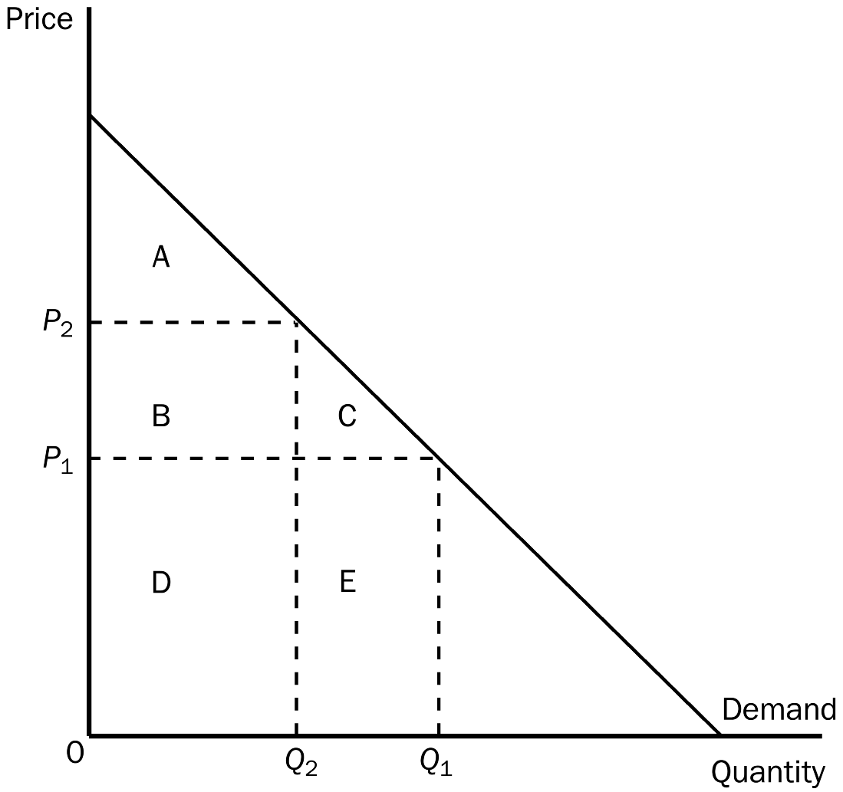
71. Refer to Figure 7-1. When the price is P₁, consumer surplus is
a. A.
b. A + B.
c. A + B + C.
d. A + B + D.
ANS: C PTS: 1 DIF: 2 REF: 7-1
TOP: Consumer surplus MSC: Interpretive
72. Refer to Figure 7-1. When the price is P₂, consumer surplus is
a. A.
b. B.
c. A + B.
d. A + B + C.
ANS: A PTS: 1 DIF: 2 REF: 7-1
TOP: Consumer surplus MSC: Interpretive
73. Refer to Figure 7-1. When the price rises from P₁ to P₂, consumer surplus
a. increases by an amount equal to A.
b. decreases by an amount equal to B + C.
c. increases by an amount equal to B + C.
d. decreases by an amount equal to C.
ANS: B PTS: 1 DIF: 2 REF: 7-1
TOP: Consumer surplus MSC: Interpretive
74. Refer to Figure 7-1. Area C represents
a. the decrease in consumer surplus that results from a downward-sloping demand curve.
b. consumer surplus to new consumers who enter the market when the price falls from P₂ to P₁.
c. the increase in producer surplus when quantity sold increases from Q₂ to Q₁.
d. the decrease in consumer surplus to each consumer in the market when the price increases from P₁ to P₂.
ANS: B PTS: 1 DIF: 3 REF: 7-1
TOP: Consumer surplus MSC: Applicative
75. Refer to Figure 7-1. When the price rises from P₁ to P₂, which of the following statements is not true?
a. The buyers who still buy the good are worse off because they now pay more.
b. Some buyers leave the market because they are not willing to buy the good at the higher price.
c. Buyers place a higher value on the good after the price increase.
d. Consumer surplus in the market falls.
ANS: C PTS: 1 DIF: 3 REF: 7-1
TOP: Price | Value MSC: Applicative
Figure 7-2
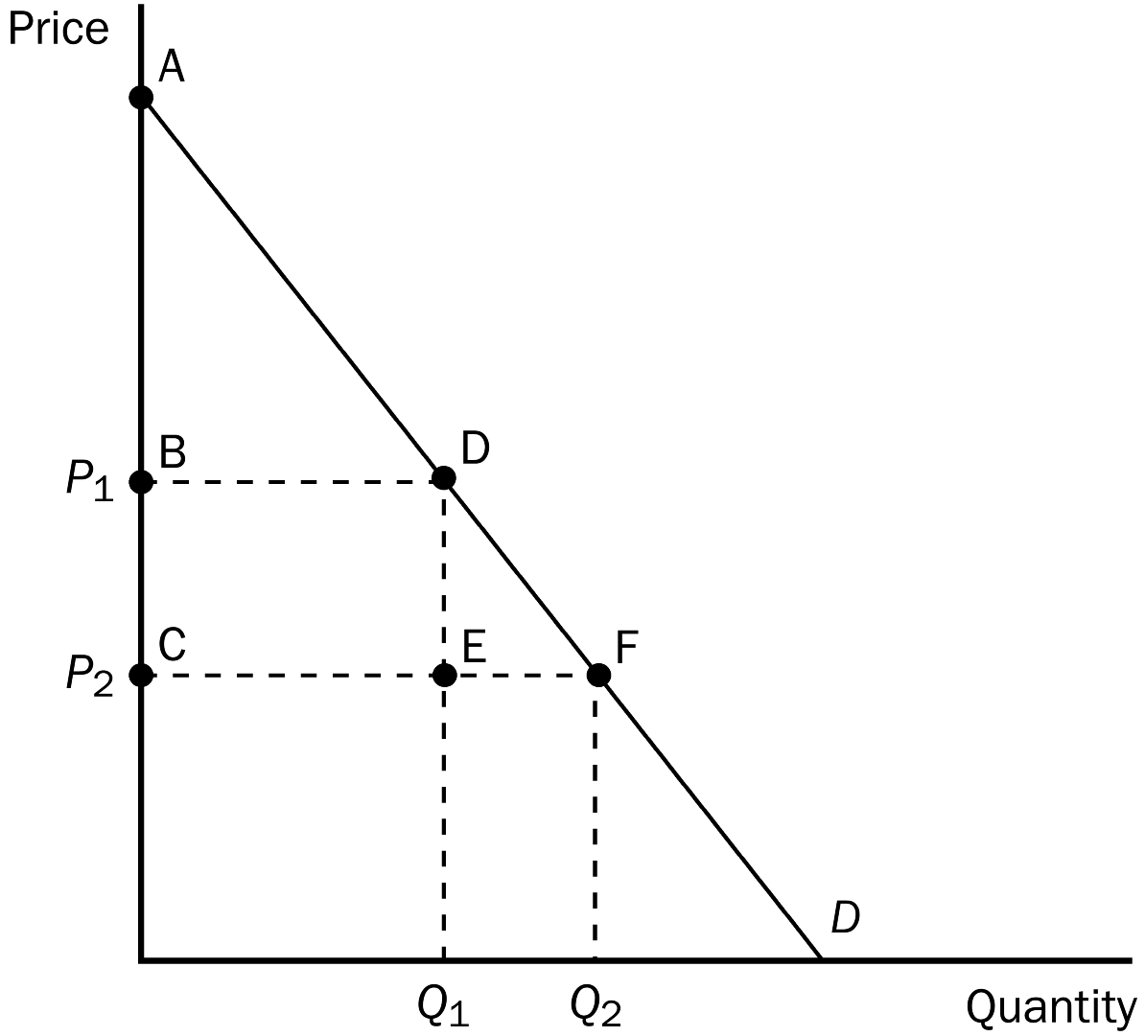
76. Refer to Figure 7-2. Which area represents consumer surplus at a price of P₁?
a. ABD
b. ACF
c. BCDE
d. DEF
ANS: A PTS: 1 DIF: 2 REF: 7-1
TOP: Consumer surplus MSC: Interpretive
77. Refer to Figure 7-2. Which area represents consumer surplus at a price of P₂?
a. ABD
b. ACF
c. BCDE
d. DEF
ANS: B PTS: 1 DIF: 2 REF: 7-1
TOP: Consumer surplus MSC: Interpretive
78. Refer to Figure 7-2. Which area represents the increase in consumer surplus when the price falls from P₁ to P₂?
a. ABD
b. ACF
c. DEF
d. BCFD
ANS: D PTS: 1 DIF: 2 REF: 7-1
TOP: Consumer surplus MSC: Applicative
79. Refer to Figure 7-2. When the price falls from P₁ to P₂, which area represents the increase in consumer surplus to existing buyers?
a. ABD
b. ACF
c. BCED
d. DEF
ANS: C PTS: 1 DIF: 2 REF: 7-1
TOP: Consumer surplus MSC: Applicative
80. Refer to Figure 7-2. When the price falls from P₁ to P₂, which area represents the increase in consumer surplus to new buyers entering the market?
a. ABD
b. ACF
c. BCDE
d. DEF
ANS: D PTS: 1 DIF: 2 REF: 7-1
TOP: Consumer surplus MSC: Applicative
Figure 7-3.
On the graph below, Q represents the quantity of the good and P represents the good’s price.
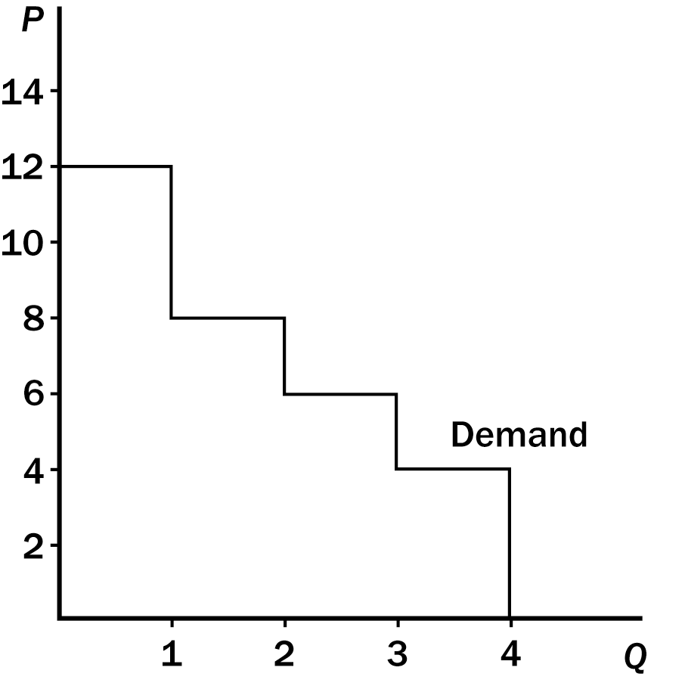
81. Refer to Figure 7-3. If the price of the good is $6, then consumer surplus is
a. $4.
b. $6.
c. $8.
d. $10.
ANS: C PTS: 1 DIF: 2 REF: 7-1
TOP: Consumer surplus MSC: Applicative
82. Refer to Figure 7-3. If the price of the good is $5, then consumer surplus is
a. $9.
b. $11.
c. $13.
d. $16.
ANS: B PTS: 1 DIF: 2 REF: 7-1
TOP: Consumer surplus MSC: Applicative
83. Dallas buys strawberries, and he would be willing to pay more than he now pays. Suppose that Dallas has a change in his tastes such that he values strawberries more than before. If the market price is the same as before, then
a. Dallas’s consumer surplus would be unaffected.
b. Dallas’s consumer surplus would increase.
c. Dallas’s consumer surplus would decrease.
d. Dallas would be wise to buy fewer strawberries than before.
ANS: B PTS: 1 DIF: 2 REF: 7-1
TOP: Consumer surplus MSC: Applicative
84. Cost is a measure of the
a. seller’s willingness to sell.
b. seller’s producer surplus.
c. producer shortage.
d. seller’s willingness to buy.
ANS: A PTS: 1 DIF: 1 REF: 7-2
TOP: Sellers MSC: Interpretive
85. Ally mows lawns for a living. Ally’s out-of-pocket expenses (for equipment, gasoline, and so on) plus the value that she places on her own time amount to her
a. producer surplus.
b. producer deficit.
c. cost of mowing lawns.
d. profit.
ANS: C PTS: 1 DIF: 1 REF: 7-2
TOP: Opportunity cost MSC: Definitional
86. A supply curve can be used to measure producer surplus because it reflects
a. the actions of sellers.
b. quantity supplied.
c. sellers’ costs.
d. the amount that will be purchased by consumers in the market.
ANS: C PTS: 1 DIF: 2 REF: 7-2
TOP: Producer surplus | Supply curve MSC: Interpretive
87. A seller is willing to sell a product only if the seller receives a price that is at least as great as
a. the seller’s producer surplus.
b. the sellers’s cost of production.
c. the seller’s profit.
d. the average willingness to pay of buyers of the product.
ANS: B PTS: 1 DIF: 2 REF: 7-2
TOP: Sellers | Price MSC: Interpretive
88. Producer surplus is
a. measured using the demand curve for a good.
b. always a negative number for sellers in a competitive market.
c. the amount a seller is paid minus the cost of production.
d. the opportunity cost of production minus the cost of producing goods that go unsold.
ANS: C PTS: 1 DIF: 2 REF: 7-2
TOP: Producer surplus MSC: Definitional
89. Producer surplus measures
a. the benefits to sellers of participating in a market.
b. the costs to sellers of participating in a market.
c. the price that buyers are willing to pay for sellers’ output of a good or service.
d. the benefit to sellers of producing a greater quantity of a good or service than buyers demand.
ANS: A PTS: 1 DIF: 2 REF: 7-2
TOP: Producer surplus MSC: Interpretive
90. A seller’s willingness to sell is
a. measured by the seller’s cost of production.
b. to her supply curve as a buyer’s willingness to buy is to his demand curve.
c. less than the price received if producer surplus is a positive number.
d. All of the above are correct.
ANS: D PTS: 1 DIF: 2 REF: 7-2
TOP: Price | Producer surplus MSC: Interpretive
91. Sally sharpens knives in her spare time for extra income. Buyers of her service are willing to pay $2.50 per knife for as many knives as Sally is willing to sharpen. On a particular day, she is willing to sharpen the first knife for $1.75, the second knife for $2.25, the third knife for $2.75, and the fourth knife for $3.25. Assume Sally is rational in deciding how many knives to sharpen. Her producer surplus is
a. $0.25.
b. $0.50.
c. $1.00.
d. $1.75.
ANS: C PTS: 1 DIF: 2 REF: 7-2
TOP: Producer surplus MSC: Applicative
Figure 7-4
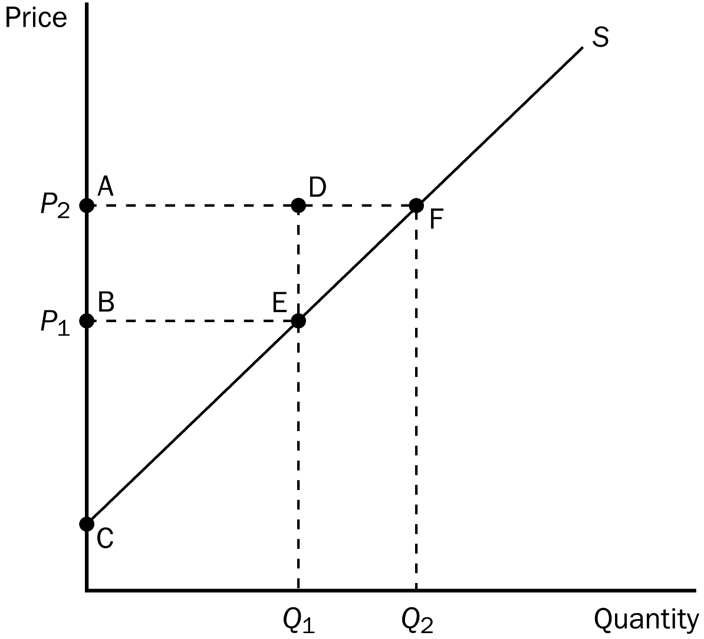
92. Refer to Figure 7-4. Which area represents producer surplus when the price is P₁?
a. BCE
b. ACF
c. ABED
d. DEF
ANS: A PTS: 1 DIF: 2 REF: 7-2
TOP: Producer surplus MSC: Interpretive
93. Refer to Figure 7-4. Which area represents producer surplus when the price is P₂?
a. BCE
b. ACF
c. ABED
d. AFEB
ANS: B PTS: 1 DIF: 2 REF: 7-2
TOP: Producer surplus MSC: Interpretive
94. Refer to Figure 7-4. Which area represents the increase in producer surplus when the price rises from P₁ to P₂?
a. BCE
b. ACF
c. ABED
d. AFEB
ANS: D PTS: 1 DIF: 2 REF: 7-2
TOP: Producer surplus MSC: Applicative
95. Refer to Figure 7-4. When the price rises from P₁ to P₂, which area represents the increase in producer surplus to existing producers?
a. BCE
b. ACF
c. DEF
d. ABED
ANS: D PTS: 1 DIF: 2 REF: 7-2
TOP: Producer surplus MSC: Applicative
96. Refer to Figure 7-4. Which area represents the increase in producer surplus when the price rises from P₁ to P₂ due to new producers entering the market?
a. BCE
b. ACF
c. DEF
d. AFEB
ANS: C PTS: 1 DIF: 2 REF: 7-2
TOP: Producer surplus MSC: Applicative
Figure 7-5. On the graph below, Q represents the quantity of the good and P represents the good’s price.
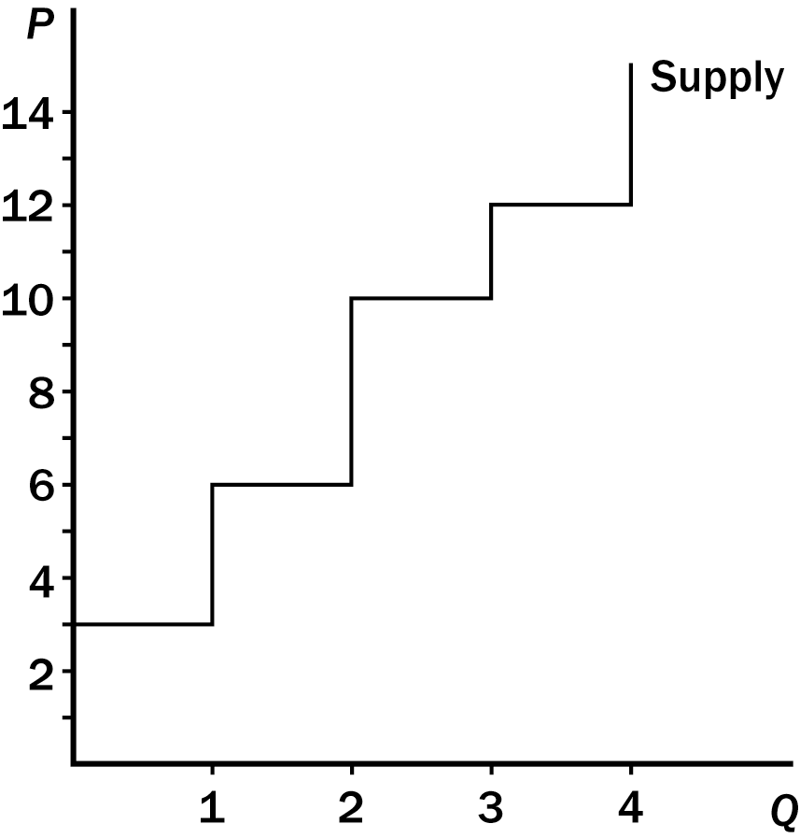
97. Refer to Figure 7-5. If the price of the good is $8.50, then producer surplus is
a. $6.50.
b. $8.00.
c. $9.50.
d. $11.00.
ANS: B PTS: 1 DIF: 2 REF: 7-2
TOP: Producer surplus MSC: Applicative
98. Refer to Figure 7-5. If the price of the good is $14, then producer surplus is
a. $17.
b. $22.
c. $25.
d. $28.
ANS: C PTS: 1 DIF: 2 REF: 7-2
TOP: Producer surplus MSC: Applicative
99. Suppose the demand for nachos increases. What will happen to producer surplus in the market for nachos?
a. It increases.
b. It decreases.
c. It remains unchanged.
d. It may increase, decrease, or remain unchanged.
ANS: A PTS: 1 DIF: 2 REF: 7-2
TOP: Producer surplus MSC: Applicative
100. If the demand for a good or service decreases, producer surplus
a. increases.
b. decreases.
c. remains the same.
d. may increase, decrease, or remain the same.
ANS: B PTS: 1 DIF: 2 REF: 7-2
TOP: Producer surplus MSC: Applicative
101. The Surgeon General announces that eating chocolate increases tooth decay. As a result, the equilibrium price of chocolate
a. increases, and producer surplus increases.
b. increases, and producer surplus decreases.
c. decreases, and producer surplus increases.
d. decreases, and producer surplus decreases.
ANS: D PTS: 1 DIF: 2 REF: 7-2
TOP: Producer surplus MSC: Applicative
102. Suppose consumer income increases. If grass seed is a normal good, the equilibrium price of grass seed will
a. decrease, and producer surplus in the industry will decrease.
b. increase, and producer surplus in the industry will increase.
c. decrease, and producer surplus in the industry will increase.
d. increase, and producer surplus in the industry will decrease.
ANS: B PTS: 1 DIF: 2 REF: 7-2
TOP: Producer surplus MSC: Applicative
103. Producer surplus equals
a. Value to buyers – Amount paid by buyers.
b. Amount received by sellers – Costs of sellers.
c. Value to buyers – Costs of sellers.
d. Value to buyers – Amount paid by buyers + Amount received by sellers – Costs of sellers.
ANS: B PTS: 1 DIF: 2 REF: 7-2
TOP: Producer surplus MSC: Definitional
104. Which of the following statements is not correct?
a. A seller would be eager to sell her product at a price higher than her cost.
b. A seller would refuse to sell her product at a price lower than her cost.
c. A seller would be indifferent about selling her product at a price equal to her cost.
d. Since sellers cannot set the price for their product, they must be willing to sell their product at any price.
ANS: D PTS: 1 DIF: 2 REF: 7-2
TOP: Sellers MSC: Interpretive
105. Producer surplus is the
a. area under the supply curve to the left of the amount sold.
b. amount a seller is paid minus the cost of production.
c. area between the supply and demand curves, above the equilibrium price.
d. cost to sellers of participating in a market.
ANS: B PTS: 1 DIF: 2 REF: 7-2
TOP: Producer surplus MSC: Definitional
106. Producer surplus is the area
a. under the supply curve.
b. between the supply and demand curves.
c. below the price and above the supply curve.
d. under the demand curve, and above the price.
ANS: C PTS: 1 DIF: 2 REF: 7-2
TOP: Producer surplus MSC: Interpretive
107. Producer surplus is
a. represented on a graph by the area below the demand curve and above the supply curve.
b. the amount a seller is paid minus the cost of production.
c. also referred to as excess supply.
d. All of the above are correct.
ANS: B PTS: 1 DIF: 2 REF: 7-2
TOP: Producer surplus MSC: Interpretive
The following table represents the costs of five possible sellers.
Table 7-4
SELLER | COST
DALE | $1,500
JILL | $1,200
DENISE | $1,000
CATHERINE | $750
JACKSON | $500

108. Refer to Table 7-4. If the market price is $1,000, the producer surplus in the market is
a. $700.
b. $750.
c. $2,250.
d. $3,700.
ANS: B PTS: 1 DIF: 2 REF: 7-2
TOP: Producer surplus MSC: Applicative
109. Refer to Table 7-4. If the market price is $1,100, the combined total cost of all participating sellers is
a. $3,700.
b. $2,700.
c. $2,250.
d. $1,500.
ANS: C PTS: 1 DIF: 2 REF: 7-2
TOP: Opportunity cost MSC: Applicative
110. Refer to Table 7-4. If the price is $1,000,
a. Denise is an eager supplier.
b. Catherine is an eager supplier.
c. Dale’s producer surplus is $500.
d. All of the above are correct.
ANS: B PTS: 1 DIF: 2 REF: 7-2
TOP: Supply | Producer surplus MSC: Applicative
111. Refer to Table 7-4. If the price is $775, who would be willing to supply the product?
a. Dale and Jill
b. Dale, Jill and Denise
c. Denise, Catherine and Jackson
d. Catherine and Jackson
ANS: D PTS: 1 DIF: 2 REF: 7-2
TOP: Supply MSC: Applicative
112. Refer to Table 7-4. Suppose each of the five sellers can supply at most one unit of the good; then the market quantity supplied is exactly 3 if the price is
a. $670.
b. $770.
c. $970.
d. $1,170.
ANS: D PTS: 1 DIF: 2 REF: 7-2
TOP: Market Supply MSC: Applicative
113. Refer to Table 7-4. Who is a marginal seller when the price is $1,200?
a. only Jill
b. Jill and Dale
c. only Denise, Catherine, and Jackson
d. Denise, Catherine, Jackson, and Jill
ANS: A PTS: 1 DIF: 2 REF: 7-2
TOP: Marginal sellers MSC: Applicative
114. The marginal seller is the seller who
a. cannot compete with the other sellers in the market.
b. would leave the market first if the price were any lower.
c. can produce at the lowest cost.
d. has the largest producer surplus.
ANS: B PTS: 1 DIF: 1 REF: 7-2
TOP: Marginal sellers MSC: Definitional
115. The marginal seller is the seller
a. for whom the marginal cost of producing one more unit of output is the lowest among all sellers, and the marginal buyer is the buyer for whom the marginal benefit of one more unit of the good is the highest among all buyers.
b. who supplies the smallest quantity of the good among all sellers, and the marginal buyer is the buyer who demands the smallest quantity of the good among all buyers.
c. who would leave the market first if the price were any lower, and the marginal buyer is the buyer who would leave the market first if the price were any higher.
d. who has the largest producer surplus, and the marginal buyer is the buyer who has the largest consumer surplus.
ANS: C PTS: 1 DIF: 2 REF: 7-2
TOP: Marginal sellers | Marginal buyers MSC: Definitional
Figure 7-6
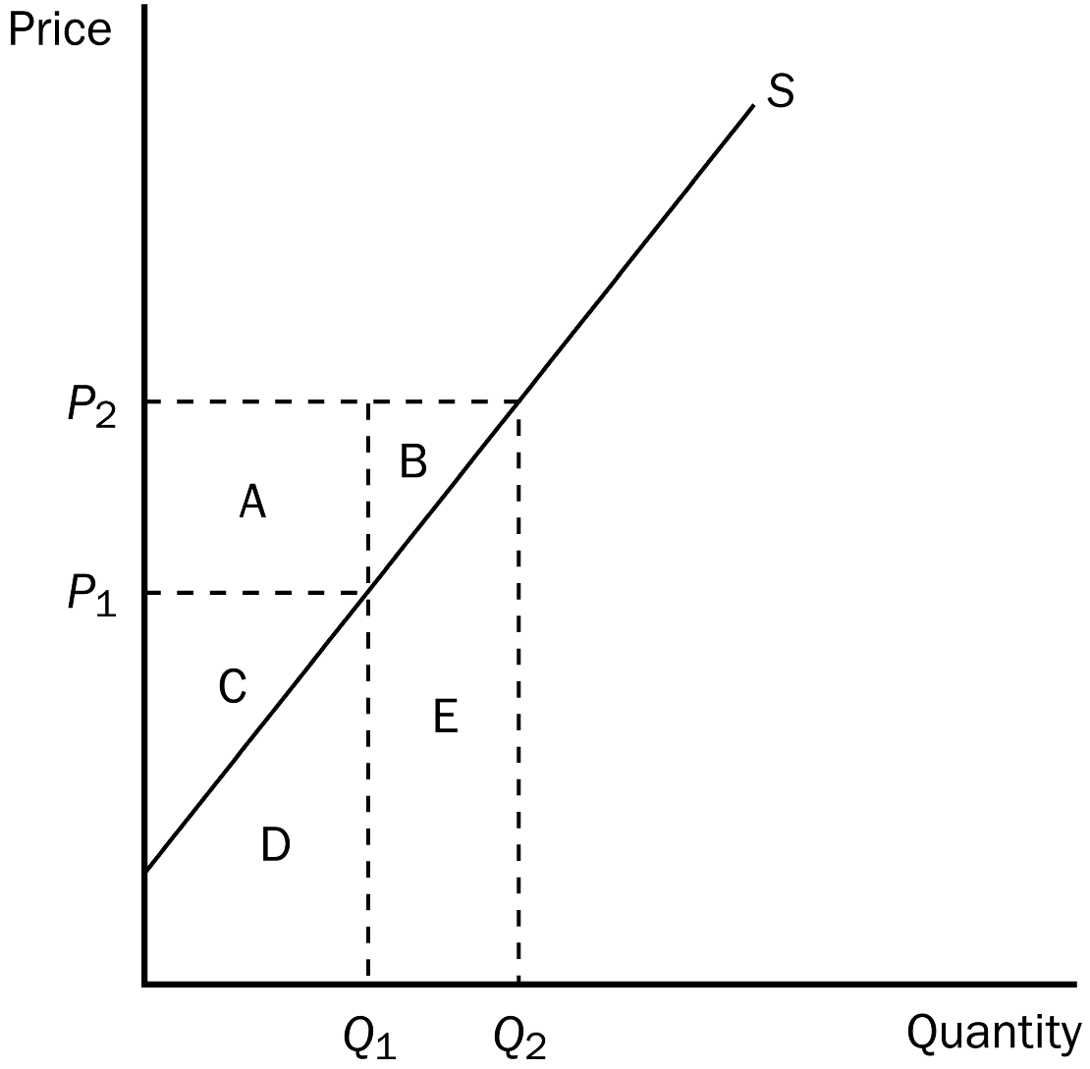
116. Refer to Figure 7-6. When the price is P₂, producer surplus is
a. A.
b. A + C.
c. A + B + C.
d. D + E.
ANS: C PTS: 1 DIF: 2 REF: 7-2
TOP: Producer surplus MSC: Interpretive
117. Refer to Figure 7-6. When the price is P₁, producer surplus is
a. A.
b. C.
c. A + B.
d. C + D.
ANS: B PTS: 1 DIF: 2 REF: 7-2
TOP: Producer surplus MSC: Interpretive
118. Refer to Figure 7-6. When the price falls from P₂ to P₁, producer surplus
a. decreases by an amount equal to C.
b. decreases by an amount equal to A + B.
c. decreases by an amount equal to A + C.
d. increases by an amount equal to A + B.
ANS: B PTS: 1 DIF: 2 REF: 7-2
TOP: Producer surplus MSC: Applicative
119. Refer to Figure 7-6. Area B represents
a. the combined profits of all producers when the price is P₂.
b. the increase in producer surplus to all producers as the result of an increase in the price from P₁ to P₂.
c. producer surplus to new producers entering the market as the result of an increase in the price from P₁ to P₂.
d. that portion of the increase in producer surplus that is offset by a loss in consumer surplus when the price increases from P₁ to P₂.
ANS: C PTS: 1 DIF: 3 REF: 7-2
TOP: Producer surplus MSC: Applicative
120. Refer to Figure 7-6. When the price falls from P₂ to P₁, which of the following would not be true?
a. The sellers who still sell the good are worse off because they now receive less.
b. Some sellers leave the market because they are not willing to sell the good at the lower price.
c. The total cost of what is now sold by sellers is actually higher than it was before the decrease in the price.
d. Producer surplus would fall by area A + B.
ANS: C PTS: 1 DIF: 2 REF: 7-2
TOP: Producer surplus MSC: Applicative
121. Refer to Figure 7-6. Area A represents
a. producer surplus to new producers entering the market as the result of an increase in price from P₁ to P₂.
b. the increase in consumer surplus that results from an upward-sloping supply curve.
c. the increase in total surplus when sellers are willing and able to increase supply from Q₁ to Q₂.
d. the increase in producer surplus to those producers already in the market when the price increases from P₁ to P₂.
ANS: D PTS: 1 DIF: 3 REF: 7-2
TOP: Producer surplus MSC: Applicative
122. Producer surplus directly measures
a. the well-being of society as a whole.
b. the well-being of buyers and sellers.
c. the well-being of sellers.
d. sellers’ willingness to sell.
ANS: C PTS: 1 DIF: 1 REF: 7-2
TOP: Producer surplus MSC: Interpretive
123. Producer surplus directly measures
a. the well-being of sellers.
b. production costs.
c. excess demand.
d. unsold inventories.
ANS: A PTS: 1 DIF: 1 REF: 7-2
TOP: Producer surplus MSC: Interpretive
124. Ivana produces cookies. Her production cost is $6 per dozen. She sells the cookies for $8 per dozen. Her producer surplus per dozen cookies is
a. $2.
b. $6.
c. $8.
d. $14.
ANS: A PTS: 1 DIF: 1 REF: 7-2
TOP: Producer surplus MSC: Interpretive
125. Donald produces nails at a cost of $200 per ton. If he sells the nails for $350 per ton, his producer surplus per ton is
a. $150.
b. $200.
c. $350.
d. $550.
ANS: A PTS: 1 DIF: 1 REF: 7-2
TOP: Producer surplus MSC: Interpretive
126. If Roberta sells a shirt for $30, and her producer surplus from the sale is $23, her cost must have been
a. $53.
b. $30.
c. $7.
d. We would have to know the consumer surplus in order to make this determination.
ANS: C PTS: 1 DIF: 1 REF: 7-2
TOP: Producer surplus MSC: Interpretive
127. Ronnie operates a lawn-care service. On each day, the cost of mowing the first lawn is $10; the cost of mowing the second lawn is $12; and the cost of mowing the third lawn is $15. His producer surplus on the first three lawns of the day is $53. If Ronnie charges all customers the same price for lawn mowing, that price is
a. $25.
b. $30.
c. $36.
d. $45.
ANS: B PTS: 1 DIF: 2 REF: 7-2
TOP: Producer surplus MSC: Applicative
128. At Nick’s Bakery, the cost to make homemade chocolate cake is $3 per cake. As a result of selling three cakes, Nick experiences a producer surplus in the amount of $19.50. Nick must be selling his cakes for
a. $6.50 each.
b. $7.50 each.
c. $9.50 each.
d. $10.50 each.
ANS: C PTS: 1 DIF: 2 REF: 7-2
TOP: Producer surplus MSC: Applicative
129. Kristi and Rebecca sell lemonade on the corner. It costs them 7 cents to make each cup. On a certain day, they sell 40 cups, and their producer surplus for that day amounts to $15.20. Kristi and Rebecca sold each cup for
a. 15 cents.
b. 30 cents.
c. 45 cents.
d. 55 cents.
ANS: C PTS: 1 DIF: 2 REF: 7-2
TOP: Producer surplus MSC: Applicative
130. Which of the following events would increase producer surplus?
a. Sellers’ costs stay the same and the price of the good increases.
b. Sellers’ costs increase and the price of the good stays the same.
c. Sellers’ costs increase and the price of the good decreases.
d. All of the above are correct.
ANS: A PTS: 1 DIF: 1 REF: 7-2
TOP: Producer surplus MSC: Interpretive

Market Supply and Demand for Pepperoni Pizza
Table 7-5
PRICE | QUANTITY  DEMANDED | QUANTITY  SUPPLIED
$12.00 | 0 | 12
$10.00 | 4 | 10
$ 8.00 | 8 | 8
$ 6.00 | 12 | 6
$ 4.00 | 16 | 4
$ 2.00 | 20 | 2

131. Refer to Table 7-5. The equilibrium or market-clearing price is
a. $10.00.
b. $8.00.
c. $6.00.
d. $4.00.
ANS: B PTS: 1 DIF: 1 REF: 7-3
TOP: Equilibrium price MSC: Interpretive
132. Refer to Table 7-5. At a price of $4.00, total surplus is
a. more than it would be at the equilibrium price.
b. less than it would be at the equilibrium price.
c. the same as it would be at the equilibrium price.
d. There is insufficient information to make this determination.
ANS: B PTS: 1 DIF: 2 REF: 7-3
TOP: Total surplus MSC: Interpretive
133. Refer to Table 7-5. As the table suggests, the demand curve is a straight line and so is the supply curve. Taking this into account, when there is equilibrium, consumer surplus is
a. $4.
b. $8.
c. $12.
d. $16.
ANS: D PTS: 1 DIF: 3 REF: 7-3
TOP: Consumer surplus MSC: Applicative
134. Refer to Table 7-5. As the table suggests, the demand curve is a straight line and so is the supply curve. Taking this into account, when there is equilibrium, producer surplus is
a. $16.
b. $24.
c. $32.
d. $48.
ANS: C PTS: 1 DIF: 3 REF: 7-3
TOP: Producer surplus MSC: Applicative
135. Refer to Table 7-5. As the table suggests, the demand curve is a straight line and so is the supply curve. Taking this into account, when there is equilibrium, total surplus is
a. $44.
b. $48.
c. $54.
d. $68.
ANS: B PTS: 1 DIF: 3 REF: 7-3
TOP: Total surplus MSC: Applicative
136. Refer to Table 7-5. As the table suggests, the demand curve is a straight line and so is the supply curve. Take this into account and suppose the price is $8, with only 4 pizzas being bought and sold. Consumer surplus amounts to
a. $8.
b. $12.
c. $16.
d. $18.
ANS: B PTS: 1 DIF: 3 REF: 7-3
TOP: Consumer surplus MSC: Applicative
137. Refer to Table 7-5. As the table suggests, the demand curve is a straight line and so is the supply curve. Take this into account and suppose the price is $8, with only 4 pizzas being bought and sold. Producer surplus amounts to
a. $24.
b. $28.
c. $32.
d. $40.
ANS: A PTS: 1 DIF: 3 REF: 7-3
TOP: Producer surplus MSC: Applicative
138. Refer to Table 7-5. As the table suggests, the demand curve is a straight line and so is the supply curve. Take this into account and suppose the price is $8, with only 4 pizzas being bought and sold. Total surplus amounts to
a. $20.
b. $30.
c. $36.
d. $40.
ANS: C PTS: 1 DIF: 3 REF: 7-3
TOP: Total surplus MSC: Applicative
Figure 7-7
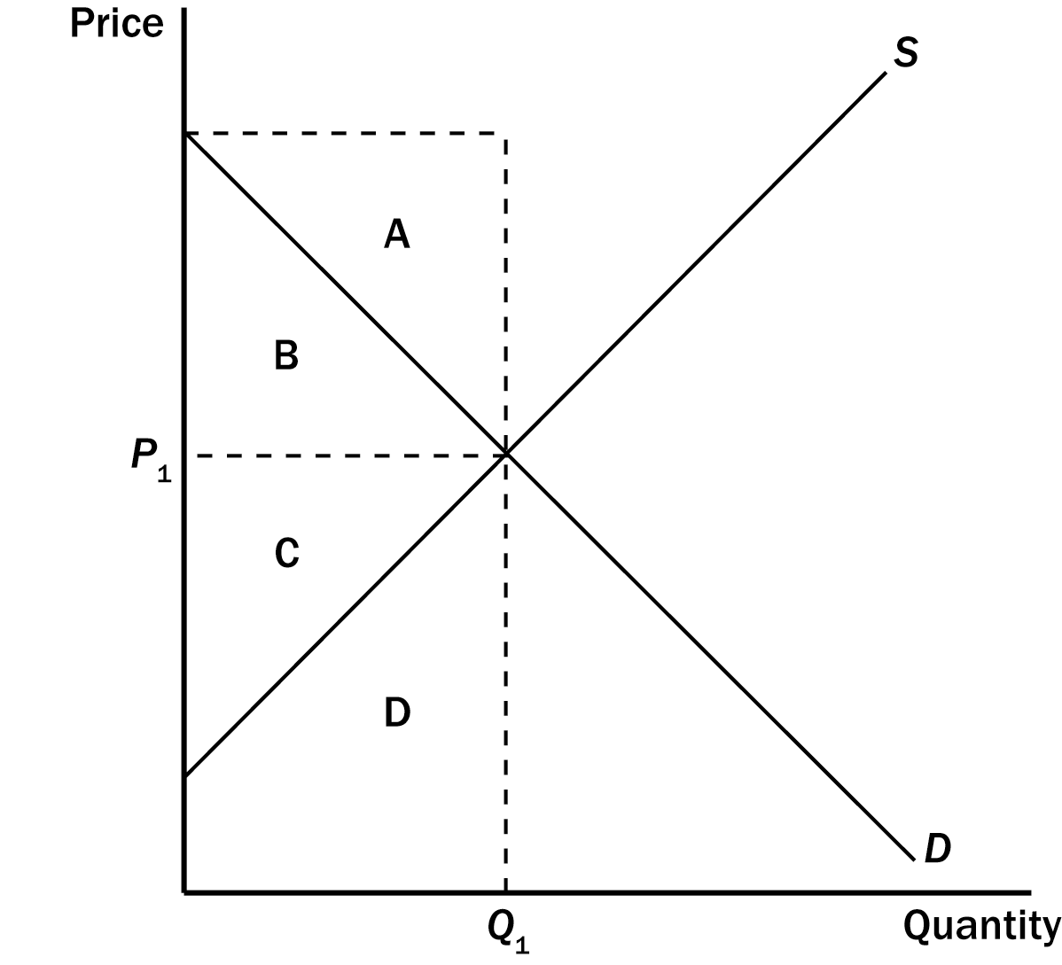
139. Refer to Figure 7-7. Which area represents consumer surplus when the price is P₁?
a. A
b. B
c. C
d. D
ANS: B PTS: 1 DIF: 2 REF: 7-3
TOP: Consumer surplus MSC: Interpretive
140. Refer to Figure 7-7. Which area represents producer surplus when the price is P₁?
a. A
b. B
c. C
d. D
ANS: C PTS: 1 DIF: 2 REF: 7-3
TOP: Producer surplus MSC: Interpretive
141. Refer to Figure 7-7. Which area represents total surplus in the market when the price is P₁?
a. A + B
b. B + C
c. C + D
d. A + B + C + D
ANS: B PTS: 1 DIF: 2 REF: 7-3
TOP: Total surplus MSC: Interpretive
142. We can say that the allocation of resources is efficient if
a. producer surplus is maximized.
b. consumer surplus is maximized.
c. total surplus is maximized.
d. sellers’ costs are minimized.
ANS: C PTS: 1 DIF: 2 REF: 7-3
TOP: Total surplus | Efficiency MSC: Interpretive
143. Efficiency in a market is achieved when
a. a social planner intervenes and sets the quantity of output after evaluating buyers’ willingness to pay and sellers’ costs.
b. the sum of producer surplus and consumer surplus is maximized.
c. all firms are producing the good at the same low cost per unit.
d. no buyer is willing to pay more than the equilibrium price for any unit of the good.
ANS: B PTS: 1 DIF: 2 REF: 7-3
TOP: Efficiency MSC: Interpretive
144. Which of the following equations is not valid?
a. Consumer surplus = Value to buyers - Amount paid by buyers
b. Producer surplus = Amount received by sellers - Cost to sellers
c. Total surplus = Value to buyers - Amount paid by buyers + Amount received by sellers - Costs of sellers
d. Total surplus = Value to sellers - Cost to sellers
ANS: D PTS: 1 DIF: 2 REF: 7-3
TOP: Total surplus MSC: Definitional
145. Which of the following equations is valid?
a. Consumer surplus = Total surplus – Cost to sellers
b. Producer surplus = Total surplus – Consumer surplus
c. Total surplus = Value to buyers – Amount paid by buyers
d. Total surplus = Amount received by sellers – Cost to sellers
ANS: B PTS: 1 DIF: 2 REF: 7-3
TOP: Total surplus MSC: Definitional
146. Total surplus
a. can be used to measure society’s well-being.
b. is the sum of consumer and producer surplus.
c. amounts to value to buyers minus cost to sellers.
d. All of the above are correct.
ANS: D PTS: 1 DIF: 2 REF: 7-3
TOP: Total surplus MSC: Interpretive
147. Total surplus in a market is
a. the total cost to sellers of providing the good minus the total value of the good to buyers.
b. the total value of the good to buyers minus the cost to sellers of providing the good.
c. the difference between consumer surplus and sellers’ cost.
d. always smaller than producer surplus.
ANS: B PTS: 1 DIF: 2 REF: 7-3
TOP: Total surplus MSC: Interpretive
148. In a market, total surplus is
a. equal to producer surplus plus consumer surplus.
b. equal to the total cost to sellers minus the total value to buyers.
c. equal to consumers’ willingness to pay plus producers’ cost.
d. greater than the sum of consumer surplus plus producer surplus.
ANS: A PTS: 1 DIF: 1 REF: 7-3
TOP: Total surplus MSC: Definitional
149. Total surplus in a market is represented by the total area
a. under the demand curve and above the price.
b. above the supply curve and up to the equilibrium price.
c. under price and up to the point of equilibrium.
d. between the demand and supply curves up to the point of equilibrium.
ANS: D PTS: 1 DIF: 2 REF: 7-3
TOP: Total surplus MSC: Interpretive
150. Total surplus in a market is the total area
a. below the demand curve and above the price.
b. below price and up to the point of equilibrium.
c. below the demand curve and above the supply curve, up to the equilibrium quantity.
d. below the demand curve and above the horizontal axis, up to the equilibrium quantity.
ANS: C PTS: 1 DIF: 2 REF: 7-3
TOP: Total surplus MSC: Interpretive
151. At the equilibrium price of a good, the good will be purchased by those buyers who
a. value the good more than price.
b. value the good less than price.
c. have the money to buy the good.
d. consider the good a necessity.
ANS: A PTS: 1 DIF: 1 REF: 7-3
TOP: Equilibrium price | Value MSC: Interpretive
Figure 7-8
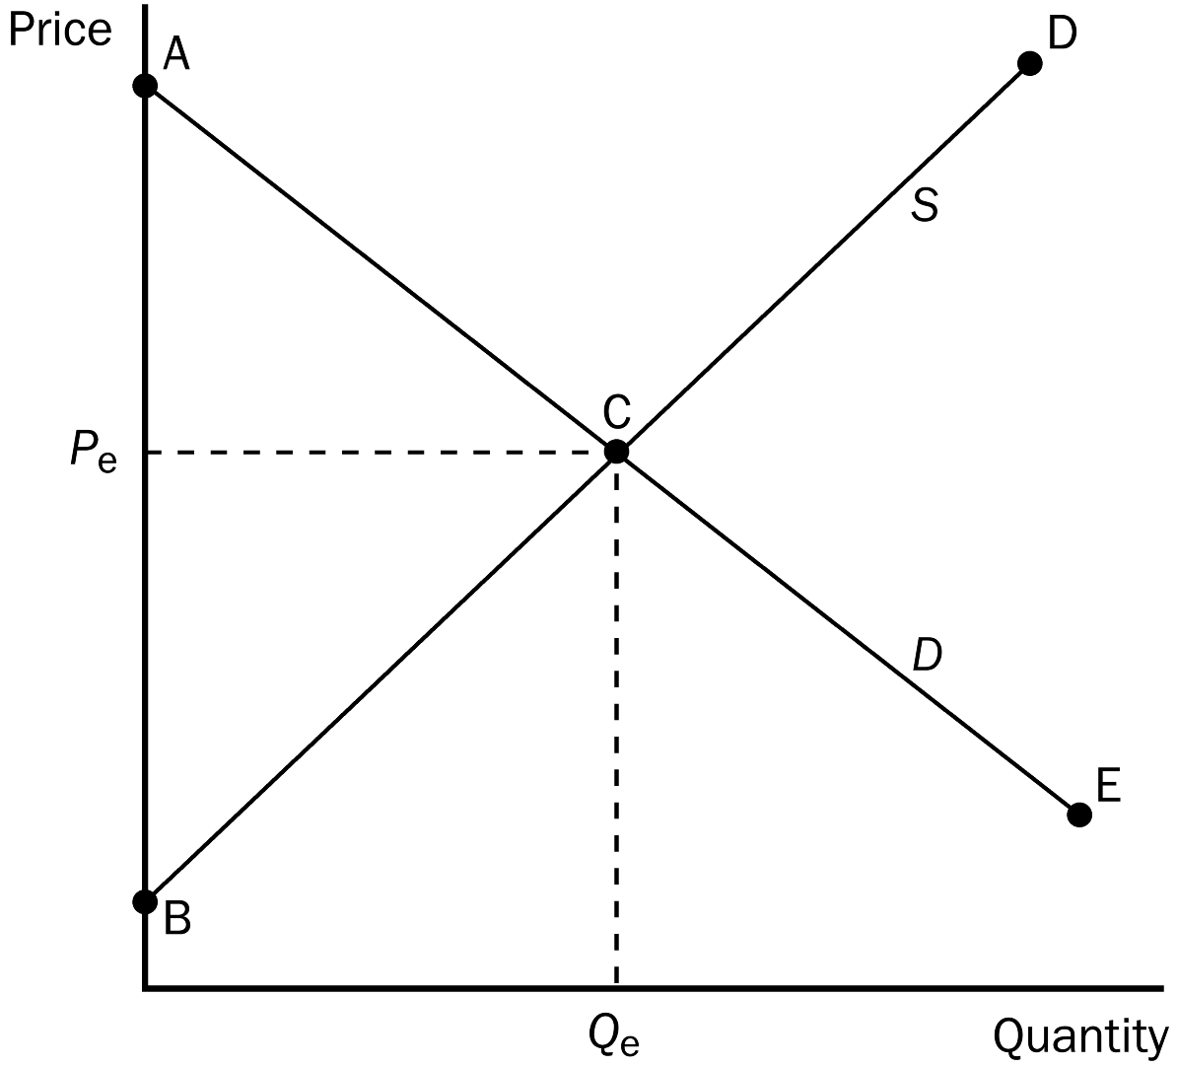
152. Refer to Figure 7-8. Buyers who value this good more than price are represented by which line segment?
a. AC.
b. CE.
c. BC.
d. CD.
ANS: A PTS: 1 DIF: 1 REF: 7-3
TOP: Price | Value MSC: Interpretive
153. Refer to Figure 7-8. Buyers who value this good less than price are represented by which line segment?
a. AC.
b. CE.
c. BC.
d. CD.
ANS: B PTS: 1 DIF: 1 REF: 7-3
TOP: Price | Value MSC: Interpretive
154. Refer to Figure 7-8. Sellers whose costs are less than price are represented by which line segment?
a. AC.
b. CE.
c. BC.
d. CD.
ANS: C PTS: 1 DIF: 1 REF: 7-3
TOP: Sellers | Price MSC: Interpretive
155. Refer to Figure 7-8. Sellers whose costs are greater than price are represented by segment
a. AC.
b. CE.
c. BC.
d. CD.
ANS: D PTS: 1 DIF: 1 REF: 7-3
TOP: Sellers | Price MSC: Interpretive
156. Refer to Figure 7-8. If the government mandated a price increase from P_{e} to a higher price, then
a. total surplus would decrease.
b. consumer surplus would increase.
c. total surplus would increase, since producer surplus would increase.
d. total surplus would remain unchanged.
ANS: A PTS: 1 DIF: 2 REF: 7-3
TOP: Total surplus MSC: Interpretive
157. Total surplus in a market is equal to
a. Value to buyers - Amount paid by buyers.
b. Amount received by sellers - Costs of sellers.
c. Value to buyers - Costs of sellers.
d. Amount received by sellers - Amount paid by buyers.
ANS: C PTS: 1 DIF: 2 REF: 7-3
TOP: Total surplus MSC: Interpretive
158. Total surplus in a market is equal to
a. Consumer surplus + Producer surplus.
b. Value to buyers - Amount paid by buyers.
c. Amount received by sellers - Costs of sellers.
d. Producer surplus - Consumer surplus.
ANS: A PTS: 1 DIF: 1 REF: 7-3
TOP: Total surplus MSC: Definitional
159. Total surplus is equal to
a. value to buyers minus profit to sellers.
b. value to buyers minus cost to sellers.
c. consumer surplus minus producer surplus.
d. (consumer surplus plus producer surplus) times equilibrium quantity.
ANS: B PTS: 1 DIF: 2 REF: 7-3
TOP: Consumer surplus | Producer surplus | Total surplus MSC: Interpretive
Figure 7-9
160. Refer to Figure 7-9. At the equilibrium price, consumer surplus is
a. $480.
b. $640.
c. $1,120.
d. $1,280.
ANS: A PTS: 1 DIF: 3 REF: 7-3
TOP: Consumer surplus MSC: Applicative
161. Refer to Figure 7-9. If the price decreases from $22 to $16, consumer surplus increases by
a. $120.
b. $360.
c. $480.
d. $600.
ANS: B PTS: 1 DIF: 3 REF: 7-3
TOP: Consumer surplus MSC: Applicative
162. Refer to Figure 7-9. At the equilibrium price, producer surplus is
a. $480.
b. $640.
c. $1,120.
d. $1,280.
ANS: B PTS: 1 DIF: 3 REF: 7-3
TOP: Producer surplus MSC: Applicative
163. Refer to Figure 7-9. At the equilibrium price, total surplus is
a. $480.
b. $640.
c. $1,120.
d. $1,280.
ANS: C PTS: 1 DIF: 3 REF: 7-3
TOP: Total surplus MSC: Applicative
164. Refer to Figure 7-9. Assume demand increases and as a result, equilibrium price increases to $22 and equilibrium quantity increases to 110. The increase in producer surplus due to new producers entering the market would be equal to
a. $90.
b. $210.
c. $360.
d. $480.
ANS: A PTS: 1 DIF: 3 REF: 7-3
TOP: Producer surplus MSC: Applicative
165. Refer to Figure 7-9. Assume demand increases and as a result, equilibrium price increases to $22 and equilibrium quantity increases to 110. The increase in producer surplus to producers already in the market would be equal to
a. $90.
b. $210.
c. $360.
d. $480.
ANS: D PTS: 1 DIF: 3 REF: 7-3
TOP: Producer surplus MSC: Applicative
166. Refer to Figure 7-9. Assume demand increases and as a result, equilibrium price increases to $22 and equilibrium quantity increases to 110. The increase in producer surplus is equal to
a. $210.
b. $360.
c. $480.
d. $570.
ANS: D PTS: 1 DIF: 3 REF: 7-3
TOP: Producer surplus MSC: Applicative
167. Refer to Figure 7-9. The efficient price is
a. $22 and the efficient quantity is 40.
b. $22 and the efficient quantity is 110.
c. $16 and the efficient quantity is 80.
d. $8 and the efficient quantity is 40.
ANS: C PTS: 1 DIF: 1 REF: 7-3
TOP: Efficiency MSC: Interpretive
168. Refer to Figure 7-9. If 110 units of the good are being bought and sold, then
a. the cost to sellers is equal to the value to buyers.
b. the value to buyers is greater than the cost to sellers.
c. the cost to sellers is greater than the value to buyers.
d. producer surplus is greater than consumer surplus.
ANS: C PTS: 1 DIF: 2 REF: 7-3
TOP: Inefficiency MSC: Interpretive
169. Refer to Figure 7-9. If 40 units of the good are being bought and sold, then
a. cost to sellers is equal to the value to buyers.
b. the value to buyers is greater than the cost to sellers.
c. the cost to sellers is greater than the value to buyers.
d. producer surplus would be greater than consumer surplus.
ANS: B PTS: 1 DIF: 2 REF: 7-3
TOP: Inefficiency MSC: Interpretive
Figure 7-10
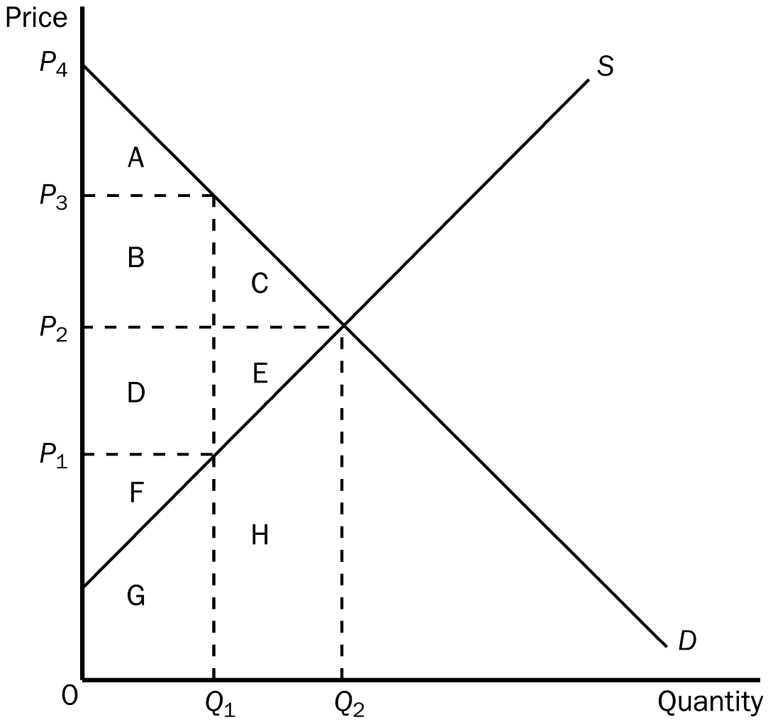
170. Refer to Figure 7-10. The equilibrium (market-clearing) price is
a. P₁.
b. P₂.
c. P₃.
d. P₄.
ANS: B PTS: 1 DIF: 1 REF: 7-3
TOP: Equilibrium price MSC: Interpretive
171. Refer to Figure 7-10. At the equilibrium, total consumer surplus is represented by the area
a. A.
b. A + B + C.
c. D + E + F.
d. A + B + C + D + E + F.
ANS: B PTS: 1 DIF: 2 REF: 7-3
TOP: Consumer surplus MSC: Interpretive
172. Refer to Figure 7-10. At the market-clearing equilibrium, total producer surplus is represented by the area
a. F.
b. F + G.
c. D + E + F.
d. D + E + F + G + H.
ANS: C PTS: 1 DIF: 2 REF: 7-3
TOP: Producer surplus MSC: Interpretive
173. Refer to Figure 7-10. At the market-clearing equilibrium, total surplus is represented by the area
a. A + B + C.
b. A + B + D + F.
c. A + B + C + D + E + F.
d. A + B + C + D + E + F + G + H.
ANS: C PTS: 1 DIF: 2 REF: 7-3
TOP: Total surplus MSC: Interpretive
174. Refer to Figure 7-10. The efficient price-quantity combination is
a. P₁ and Q₁.
b. P₂ and Q₂.
c. P₃ and Q₁.
d. P₄ and 0.
ANS: B PTS: 1 DIF: 1 REF: 7-3
TOP: Efficiency | Equilibrium MSC: Interpretive
Figure 7-11. On the graph below, Q represents the quantity of the good and P represents the good’s price.
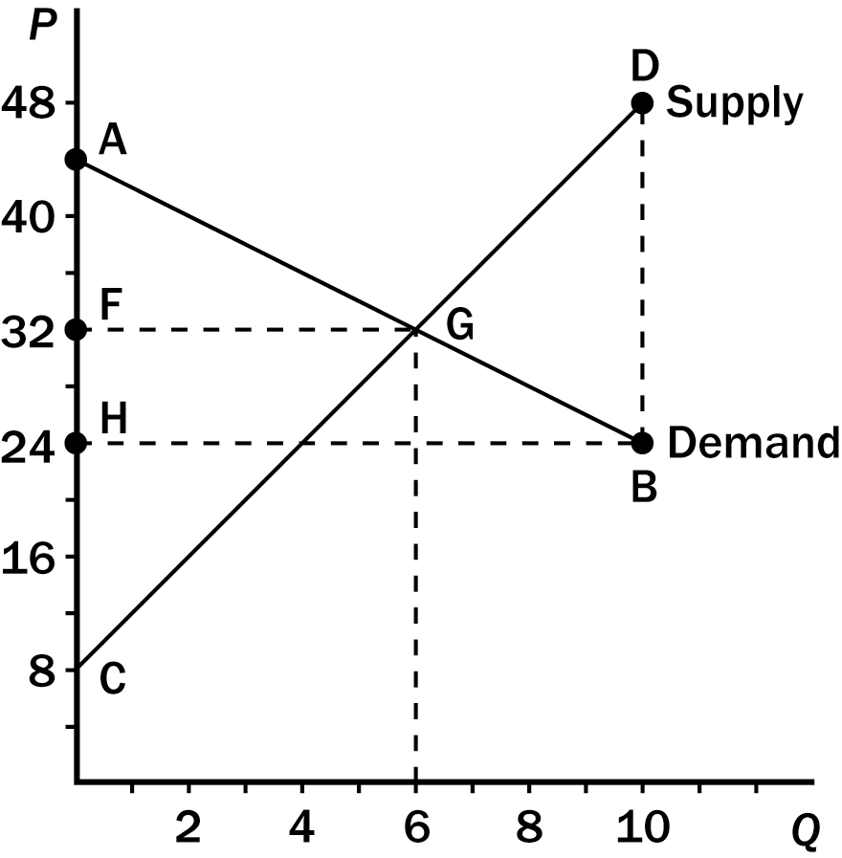
175. Refer to Figure 7-11. At the equilibrium, consumer surplus is measured by the area
a. ACG.
b. AFG.
c. DBG.
d. CFG.
ANS: B PTS: 1 DIF: 1 REF: 7-3
TOP: Consumer surplus MSC: Interpretive
176. Refer to Figure 7-11. At the equilibrium, producer surplus is measured by the area
a. ACG.
b. AFG.
c. DBG.
d. CFG.
ANS: D PTS: 1 DIF: 1 REF: 7-3
TOP: Producer surplus MSC: Interpretive
177. Refer to Figure 7-11. At the equilibrium, total surplus is measured by the area
a. ACG.
b. AFG.
c. DBG.
d. CFG.
ANS: A PTS: 1 DIF: 1 REF: 7-3
TOP: Total surplus MSC: Interpretive
178. Refer to Figure 7-11. At the equilibrium, consumer surplus amounts to
a. $24.
b. $36.
c. $48.
d. $72.
ANS: B PTS: 1 DIF: 3 REF: 7-3
TOP: Consumer surplus MSC: Analytical
179. Refer to Figure 7-11. At the equilibrium, producer surplus amounts to
a. $32.
b. $48.
c. $72.
d. $144.
ANS: C PTS: 1 DIF: 3 REF: 7-3
TOP: Producer surpluss MSC: Analytical
180. Refer to Figure 7-11. At the equilibrium, total surplus amounts to
a. $64.
b. $72.
c. $96.
d. $108.
ANS: D PTS: 1 DIF: 3 REF: 7-3
TOP: Total surplus MSC: Analytical
181. Refer to Figure 7-11. The equilibrium allocation of resources is
a. efficient because total surplus is maximized at the equilibrium.
b. efficient because consumer surplus is maximized at the equilibrium.
c. inefficient because consumer surplus is larger than producer surplus at the equilibrium.
d. inefficient because total surplus is maximized when 10 units of output are produced and sold.
ANS: A PTS: 1 DIF: 2 REF: 7-3
TOP: Efficiency MSC: Interpretive
182. Refer to Figure 7-11. If four units of the good are produced and sold, then
a. the cost to sellers exceeds the value to buyers.
b. producer surplus is maximized.
c. total surplus is minimized.
d. the allocation of resources is inefficient.
ANS: D PTS: 1 DIF: 2 REF: 7-3
TOP: Producer surplus | Total surplus | Efficiency MSC: Interpretive
Figure 7-12
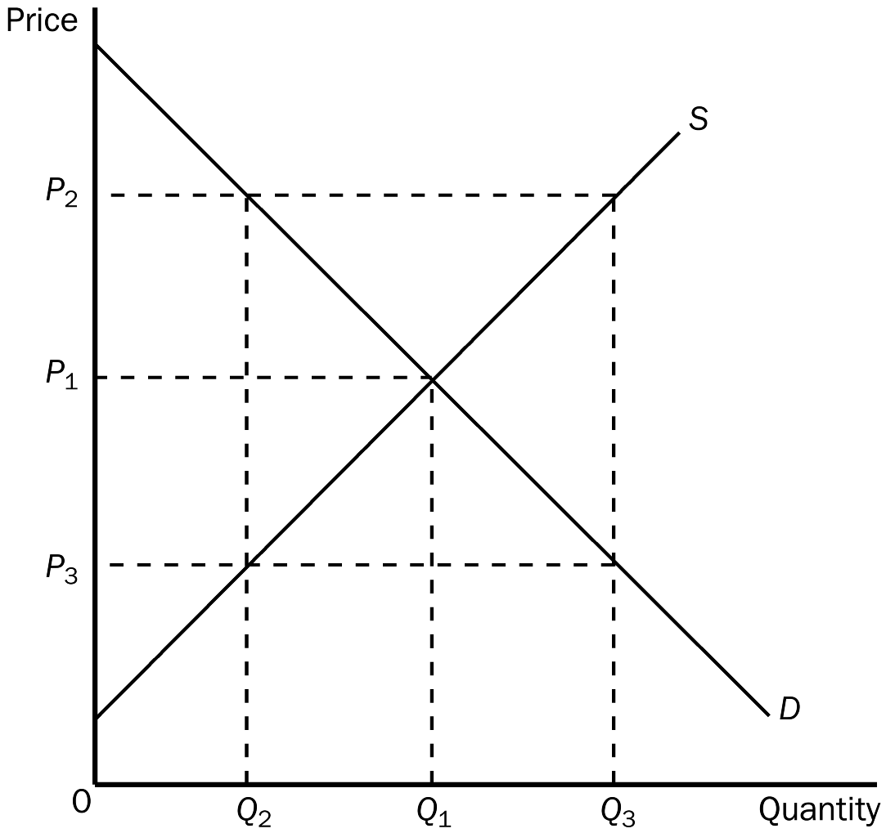
183. Refer to Figure 7-12. At the quantity Q₃,
a. the market is in equilibrium.
b. consumer surplus is maximized.
c. the sum of consumer surplus and producer surplus is maximized.
d. the value to buyers is less than the cost to sellers.
ANS: D PTS: 1 DIF: 2 REF: 7-3
TOP: Inefficiency MSC: Interpretive
184. Refer to Figure 7-12. At the quantity Q₂,
a. the value to buyers and the cost to sellers are both P₂.
b. the value to buyers is P₂ and the cost to sellers is P₃.
c. the value to buyers and the cost to sellers are both P₃.
d. the value to buyers is P₃ and the cost to sellers is P₂.
ANS: B PTS: 1 DIF: 2 REF: 7-3
TOP: Inefficiency MSC: Interpretive
185. Which of the following statements is not correct about a market in equilibrium?
a. The price determines which buyers and which sellers participate in the market.
b. Those buyers who value the good more than the price choose to buy the good.
c. Those sellers whose costs are less than the price choose to produce and sell the good.
d. Consumer surplus will be equal to producer surplus.
ANS: D PTS: 1 DIF: 2 REF: 7-3
TOP: Equilibrium MSC: Interpretive
186. Efficiency is attained when
a. total surplus is maximized.
b. producer surplus is maximized.
c. all resources are being used.
d. consumer surplus is maximized and producer surplus is minimized.
ANS: A PTS: 1 DIF: 2 REF: 7-3
TOP: Efficiency MSC: Definitional
187. The distinction between efficiency and equity can be described as follows:
a. Efficiency refers to maximizing the number of trades among buyers and sellers; equity refers to maximizing the gains from trade among buyers and sellers.
b. Efficiency refers to minimizing the price paid by buyers; equity refers to maximizing the gains from trade among buyers and sellers.
c. Efficiency refers to maximizing the size of the pie; equity refers to producing a pie of a given size at the least possible cost.
d. Efficiency refers to maximizing the size of the pie; equity refers to distributing the pie fairly among members of society.
ANS: D PTS: 1 DIF: 2 REF: 7-3
TOP: Efficiency | Equity | Gains from trade MSC: Interpretive
188. If an allocation of resources is efficient, then
a. consumer surplus is maximized.
b. producer surplus is maximized.
c. all potential gains from trade among buyers are sellers are being realized.
d. the allocation is necessarily equitable as well.
ANS: C PTS: 1 DIF: 2 REF: 7-3
TOP: Efficiency MSC: Interpretive
189. Moving production from a high-cost producer to a low-cost producer will
a. lower total surplus.
b. raise total surplus.
c. lower producer surplus.
d. raise producer surplus but lower consumer surplus.
ANS: B PTS: 1 DIF: 2 REF: 7-3
TOP: Total surplus MSC: Interpretive
190. Inefficiency exists in an economy when a good is
a. not being consumed by buyers who value it most highly.
b. not distributed fairly among buyers.
c. not produced because buyers do not value it very highly.
d. being produced with less than all available resources.
ANS: A PTS: 1 DIF: 2 REF: 7-3
TOP: Inefficiency MSC: Interpretive
191. Inefficiency exists in an economy when a good is
a. being produced with less than all available resources.
b. not distributed fairly among buyers.
c. not being produced by the lowest-cost producers.
d. being consumed by buyers who value it most highly.
ANS: C PTS: 1 DIF: 2 REF: 7-3
TOP: Inefficiency MSC: Interpretive
192. Which of the following is correct?
a. Efficiency deals with the size of the economic pie and equity deals with how fairly the pie is sliced.
b. Equity can be judged on positive grounds whereas efficiency requires normative judgments.
c. Efficiency is more difficult to evaluate than equity.
d. Equity and efficiency are both maximized in a society when total surplus is maximized.
ANS: A PTS: 1 DIF: 2 REF: 7-3
TOP: Efficiency MSC: Interpretive
193. If the government allowed a free market for transplant organs (such as kidneys) to exist,
a. the shortage of organs would be eliminated and there would be no surplus of organs.
b. the shortage of organs would be eliminated, but a surplus of organs would develop.
c. the shortage of organs would persist.
d. the overall well-being of society would remain unchanged.
ANS: A PTS: 1 DIF: 2 REF: 7-3
TOP: Price ceilings | Inefficiency MSC: Interpretive
194. The “invisible hand” refers to
a. the marketplace guiding the self-interests of market participants into promoting general economic well-being.
b. the fact that social planners sometimes have to intervene, even in perfectly competitive markets, to make those markets more efficient.
c. the equity that results from market forces allocating the goods produced in the market.
d. the automatic maximization of consumer surplus in free markets.
ANS: A PTS: 1 DIF: 2 REF: 7-3
TOP: Invisible hand MSC: Interpretive
195. The “invisible hand” is
a. used to describe the welfare system in the United States.
b. a concept developed by Adam Smith to describe the virtues of free markets.
c. a concept used by J.M. Keynes to describe the role of government in guiding the allocation of resources in the economy.
d. a term used by some economists to characterize the role of government in an economy-- inevitable but invisible.
ANS: B PTS: 1 DIF: 2 REF: 7-3
TOP: Invisible hand MSC: Interpretive
196. Economists tend to see ticket scalping as
a. a way for a few to profit without producing anything of value.
b. an inequitable interference in the orderly process of ticket distribution.
c. a way of increasing the efficiency of ticket distribution.
d. an unproductive activity which should be made illegal everywhere.
ANS: C PTS: 1 DIF: 2 REF: 7-3
TOP: Market efficiency MSC: Interpretive
197. Laissez-faire is a French expression which literally means
a. to make do.
b. to get involved.
c. whatever works.
d. allow them to do.
ANS: D PTS: 1 DIF: 1 REF: 7-3
TOP: Laissez-faire policy MSC: Definitional
198. The French expression used by free-market advocates, which literally translates as “allow them to do,” is
a. laissez-faire.
b. je ne sais pas.
c. si’l vous plait.
d. tête-à-tête.
ANS: A PTS: 1 DIF: 1 REF: 7-3
TOP: Laissez-faire policy MSC: Definitional
199. According to many economists, government restrictions on ticket scalping do all of the following except
a. inconvenience the public.
b. reduce the audience for cultural and sports events.
c. waste the police’s time.
d. keep the cost of tickets to consumers low.
ANS: D PTS: 1 DIF: 2 REF: 7-3
TOP: Market efficiency MSC: Interpretive
200. Many economists believe that restrictions against ticket scalping result in each of the following except
a. a smaller audience for cultural and sporting events.
b. shorter lines at cultural and sporting events.
c. less tax revenue for the state.
d. an increase in ticket prices.
ANS: B PTS: 1 DIF: 2 REF: 7-3
TOP: Market efficiency MSC: Interpretive
201. Suppose that the equilibrium price in the market for widgets is $5. If a law increased the minimum legal price for widgets to $6, producer surplus
a. would necessarily increase even if the higher price resulted in a surplus of widgets.
b. would necessarily decrease because the higher price would create a surplus of widgets.
c. might increase or decrease.
d. would be unaffected.
ANS: C PTS: 1 DIF: 3 REF: 7-3
TOP: Price floors | Producer surplus MSC: Analytical
202. Suppose that the equilibrium price in the market for widgets is $5. If a law reduced the maximum legal price for widgets to $4,
a. any possible increase in consumer surplus would be larger than the loss of producer surplus.
b. any possible increase in consumer surplus would be smaller than the loss of producer surplus.
c. the resulting increase in producer surplus would be larger than any possible loss of consumer surplus.
d. the resulting increase in producer surplus would be smaller than any possible loss of consumer surplus.
ANS: B PTS: 1 DIF: 3 REF: 7-3
TOP: Price ceilings | Consumer surplus | Producer surplus MSC: Analytical
203. Suppose that the equilibrium price in the market for widgets is $5. If a law increased the minimum legal price for widgets to $6,
a. the resulting increase in consumer surplus would be larger than any possible loss of producer surplus.
b. the resulting increase in consumer surplus would be smaller than any possible loss of producer surplus.
c. any possible increase in producer surplus would be larger than the loss of consumer surplus.
d. any possible increase in producer surplus would be smaller than the loss of consumer surplus.
ANS: D PTS: 1 DIF: 3 REF: 7-3
TOP: Price floors | Consumer surplus | Producer surplus MSC: Analytical
204. At present, the maximum legal price for a human kidney is $0. The price of $0 maximizes
a. consumer surplus, but not producer surplus.
b. producer surplus, but not consumer surplus.
c. both consumer and producer surplus.
d. neither consumer nor producer surplus.
ANS: D PTS: 1 DIF: 2 REF: 7-3
TOP: Price ceilings | Consumer surplus | Producer surplus MSC: Applicative
205. If a market is allowed to adjust freely to its equilibrium price and quantity, then an increase in demand will
a. increase producer surplus.
b. reduce producer surplus.
c. not affect producer surplus.
d. increase or decrease producer surplus or leave producer surplus unchanged.
ANS: A PTS: 1 DIF: 2 REF: 7-3
TOP: Producer surplus MSC: Applicative
206. If a market is allowed to move freely to its equilibrium price and quantity, then an increase in supply will
a. increase consumer surplus.
b. reduce consumer surplus.
c. not affect consumer surplus.
d. increase or decrease consumer surplus or leave consumer surplus unchanged.
ANS: A PTS: 1 DIF: 2 REF: 7-3
TOP: Consumer surplus MSC: Applicative
207. A simultaneous increase in both the demand for radios and the supply of radios would imply that
a. both the value of radios to consumers and the cost of producing radios has increased.
b. both the value of radios to consumers and the cost of producing radios has decreased.
c. the value of radios to consumers has decreased and the cost of producing radios has increased.
d. the value of radios to consumers has increased and the cost of producing radios has decreased.
ANS: D PTS: 1 DIF: 2 REF: 7-3
TOP: Demand | Supply MSC: Interpretive
208. Cornflakes and milk are complementary goods. A decrease in the price of corn will
a. increase consumer surplus in the market for cornflakes and decrease producer surplus in the market for milk.
b. increase consumer surplus in the market for cornflakes and increase producer surplus in the market for milk.
c. decrease consumer surplus in the market for cornflakes and increase producer surplus in the market for milk.
d. decrease consumer surplus in the market for cornflakes and decrease producer surplus in the market for milk.
ANS: B PTS: 1 DIF: 3 REF: 7-3
TOP: Consumer surplus | Producer surplus MSC: Applicative
209. Orange juice and apple juice are substitutes. Bad weather that sharply reduces the orange harvest would
a. increase consumer surplus in the market for orange juice and decrease producer surplus in the market for apple juice.
b. increase consumer surplus in the market for orange juice and increase producer surplus in the market for apple juice.
c. decrease consumer surplus in the market for orange juice and increase producer surplus in the market for apple juice.
d. decrease consumer surplus in the market for orange juice and decrease producer surplus in the market for apple juice.
ANS: C PTS: 1 DIF: 3 REF: 7-3
TOP: Consumer surplus | Producer surplus MSC: Applicative
210. A technological advance in the production of computers will
a. increase consumer surplus in the market for computers and decrease producer surplus in the market for computer software.
b. increase consumer surplus in the market for computers and increase producer surplus in the market for computer software.
c. decrease consumer surplus in the market for computers and increase producer surplus in the market for computer software.
d. decrease consumer surplus in the market for computers and decrease producer surplus in the market for computer software.
ANS: B PTS: 1 DIF: 3 REF: 7-3
TOP: Consumer surplus | Producer surplus MSC: Applicative
211. Inefficiency can be caused in a market by the presence of
a. market power.
b. externalities.
c. imperfectly competitive markets.
d. All of the above are correct.
ANS: D PTS: 1 DIF: 2 REF: 7-4
TOP: Market failures MSC: Interpretive
212. Market power refers to the
a. side effects that may occur in a market.
b. government regulations imposed on the sellers in a market.
c. ability of market participants to influence price.
d. forces of supply and demand in determining equilibrium price.
ANS: C PTS: 1 DIF: 1 REF: 7-4
TOP: Market power MSC: Definitional
213. Externalities are
a. side effects passed on to a party other than the buyers and sellers in the market.
b. side effects of government intervention in markets.
c. external forces that cause the price of a good to be higher than it otherwise would be.
d. external forces that help establish equilibrium price.
ANS: A PTS: 1 DIF: 1 REF: 7-4
TOP: Externalities MSC: Definitional
214. The decisions of buyers and sellers that affect people who are not participants in the market create
a. market power.
b. externalities.
c. profiteering.
d. market equilibrium.
ANS: B PTS: 1 DIF: 1 REF: 7-4
TOP: Externalities MSC: Definitional
215. Market failure is the inability of
a. buyers to interact harmoniously with sellers in the market.
b. a market to establish an equilibrium price.
c. buyers to place a value on the good or service.
d. some unregulated markets to allocate resources efficiently.
ANS: D PTS: 1 DIF: 2 REF: 7-4
TOP: Market failures MSC: Definitional
216. When markets fail, public policy
a. can do nothing to improve the situation.
b. can potentially remedy the problem and increase economic efficiency.
c. can always remedy the problem and increase economic efficiency.
d. can, in theory, remedy the problem, but in practice, public policy has proven to be ineffective.
ANS: B PTS: 1 DIF: 2 REF: 7-4
TOP: Market failures | Public policy MSC: Interpretive
True/False
1. Welfare economics is the study of the welfare system.
ANS: F PTS: 1 DIF: 1 REF: 7-1
TOP: Economic welfare MSC: Definitional
2. The willingness to pay is the maximum amount that a buyer will pay for a good and measures how much the buyer values the good.
ANS: T PTS: 1 DIF: 1 REF: 7-1
TOP: Price | Value MSC: Definitional
3. Consumer surplus is the amount a buyer actually has to pay for a good minus the amount the buyer is willing to pay for it.
ANS: F PTS: 1 DIF: 1 REF: 7-1
TOP: Consumer surplus MSC: Definitional
4. Joel has a 1966 Mustang, which he sells to Susie, an avid car collector. Susie is pleased since she paid $8,000 for the car but would have been willing to pay $11,000 for the car. Susie’s consumer surplus is $2,000.
ANS: F PTS: 1 DIF: 1 REF: 7-1
TOP: Consumer surplus MSC: Interpretive
5. For any given quantity, the price on a demand curve represents the marginal buyer’s willingness to pay.
ANS: T PTS: 1 DIF: 2 REF: 7-1
TOP: Demand curve | Marginal buyers MSC: Interpretive
6. Consumer surplus measures the benefit to buyers of participating in a market.
ANS: T PTS: 1 DIF: 1 REF: 7-1
TOP: Consumer surplus MSC: Interpretive
7. A buyer is willing to buy a product at a price greater than or equal to his willingness to pay, but would refuse to buy a product at a price less than his willingness to pay.
ANS: F PTS: 1 DIF: 1 REF: 7-1
TOP: Price | Value MSC: Definitional
8. Each seller of a product is willing to sell as long as the price he or she can receive is greater than the opportunity cost of producing the product.
ANS: T PTS: 1 DIF: 1 REF: 7-2
TOP: Opportunity cost MSC: Interpretive
9. In a competitive market, sales go to those producers who are willing to supply the product at the lowest price.
ANS: T PTS: 1 DIF: 1 REF: 7-2
TOP: Competitive markets MSC: Interpretive
10. Producer surplus is the amount a seller is paid minus the cost of production.
ANS: T PTS: 1 DIF: 1 REF: 7-2
TOP: Producer surplus MSC: Definitional
11. Connie can clean windows in large office buildings at a cost of $1 per window. The market price for window-cleaning services is $3 per window. If Connie cleans 100 windows, her producer surplus is $100.
ANS: F PTS: 1 DIF: 2 REF: 7-2
TOP: Producer surplus MSC: Applicative
12. At any quantity, the price given by the supply curve shows the cost of the lowest-cost seller.
ANS: F PTS: 1 DIF: 2 REF: 7-2
TOP: Supply curve | Opportunity cost MSC: Interpretive
13. The area below the price and above the supply curve measures the producer surplus in a market.
ANS: T PTS: 1 DIF: 2 REF: 7-2
TOP: Producer surplus MSC: Interpretive
14. When market price increases, producer surplus increases because (1) producer surplus received by existing sellers increases, and (2) new sellers enter the market.
ANS: T PTS: 1 DIF: 2 REF: 7-2
TOP: Producer surplus MSC: Interpretive
15. Total surplus in a market is consumer surplus minus producer surplus.
ANS: F PTS: 1 DIF: 1 REF: 7-3
TOP: Total surplus MSC: Definitional
16. Total surplus = Value to buyers - Costs to sellers.
ANS: T PTS: 1 DIF: 2 REF: 7-3
TOP: Total surplus MSC: Interpretive
17. The equilibrium of supply and demand in a market maximizes the total benefits to buyers and sellers of participating in that market.
ANS: T PTS: 1 DIF: 2 REF: 7-3
TOP: Equilibrium | Total surplus MSC: Interpretive
18. Efficiency refers to whether a market outcome is fair, while equity refers to whether the maximum amount of output was produced from a given number of inputs.
ANS: F PTS: 1 DIF: 1 REF: 7-3
TOP: Efficiency | Equity MSC: Definitional
19. Efficiency is related to the size of the economic pie, whereas equity is related to how the pie gets sliced and distributed.
ANS: T PTS: 1 DIF: 1 REF: 7-3
TOP: Efficiency | Equity MSC: Definitional
20. Total surplus in a market can be measured as the area below the supply curve plus the area above the demand curve, up to the point of equilibrium.
ANS: F PTS: 1 DIF: 2 REF: 7-3
TOP: Total surplus MSC: Interpretive
21. Free markets allocate (a) the supply of goods to the buyers who value them most highly and (b) the demand for goods to the sellers who can produce them at least cost.
ANS: T PTS: 1 DIF: 2 REF: 7-3
TOP: Markets MSC: Interpretive
22. Even though participants in the economy are motivated by self-interest, the “invisible hand” of the marketplace guides this self-interest into promoting general economic well-being.
ANS: T PTS: 1 DIF: 2 REF: 7-3
TOP: Invisible hand MSC: Interpretive
23. Economists generally believe that, although there may be advantages to society from ticket-scalping, the costs to society of this activity outweigh the benefits.
ANS: F PTS: 1 DIF: 2 REF: 7-3
TOP: Market efficiency MSC: Interpretive
24. Economists argue that restrictions against ticket scalping actually drive up the cost of many tickets.
ANS: T PTS: 1 DIF: 2 REF: 7-3
TOP: Market efficiency MSC: Interpretive
25. If the United States legally allowed for the existence of a market in transplant organs, it is estimated that one kidney would sell for at least $100,000.
ANS: F PTS: 1 DIF: 2 REF: 7-3
TOP: Price ceilings MSC: Interpretive
26. Unless markets are perfectly competitive, they mail fail to maximize the total benefits to buyers and sellers.
ANS: T PTS: 1 DIF: 2 REF: 7-4
TOP: Market failures MSC: Interpretive
27. When markets fail, public policy can potentially remedy the problem and increase economic efficiency.
ANS: T PTS: 1 DIF: 2 REF: 7-4
TOP: Market failures | Public policy MSC: Interpretive
Short Answer
1. Answer each of the following questions about demand and consumer surplus.
a. What is consumer surplus, and how is it measured?
b. What is the relationship between the demand curve and the willingness to pay?
c. Other things equal, what happens to consumer surplus if the price of a good falls? Why? Illustrate using a demand curve.
d. In what way does the demand curve represent the benefit consumers receive from participating in a market? In addition to the demand curve, what else must be considered to determine consumer surplus?
ANS:
a. Consumer surplus measures the benefit to buyers of participating in a market. It is measured as the amount a buyer is willing to pay for a good minus the amount a buyer actually pays for it. For an individual purchase, consumer surplus is the difference between the willingness to pay, as shown on the demand curve, and the market price. For the market, total consumer surplus is the area under the demand curve and above the price, from the origin to the quantity purchased.
b. Because the demand curve shows the maximum amount buyers are willing to pay for a given market quantity, the price given by the demand curve represents the willingness to pay of the marginal buyer.
c. When the price of a good falls, consumer surplus increases for two reasons. First, those buyers who were already buying the good receive an increase in consumer surplus because they are paying less (area B). Second, some new buyers enter the market because the price of the good is now lower than their willingness to pay (area C); hence, there is additional consumer surplus generated from their purchases. The graph should show that as price falls from P₂ to P₁, consumer surplus increases from area A to area A + B + C.
d. Since the demand curve represents the maximum price the marginal buyer is willing to pay for a good, it must also represent the maximum benefit the buyer expects to receive from consuming the good. Consumer surplus must take into account the amount the buyer actually pays for the good, with consumer surplus measured as the difference between what the buyer is willing to pay and what he/she actually paid. Consumer surplus, then, measures the benefit the buyer didn’t have to “pay for.”
PTS: 1 DIF: 2 REF: 7-1
TOP: Demand | Consumer surplus MSC: Interpretive
2. Tammy loves donuts. The table shown reflects the value Tammy places on each donut she eats:

VALUE OF FIRST DONUT | $0.60
VALUE OF SECOND DONUT | $0.50
VALUE OF THIRD DONUT | $0.40
VALUE OF FOURTH DONUT | $0.30
VALUE OF FIFTH DONUT | $0.20
VALUE OF SIXTH DONUT | $0.10

a. Use this information to construct Tammy’s demand curve for donuts.
b. If the price of donuts is $0.20, how many donuts will Tammy buy?
c. Show Tammy’s consumer surplus on your graph. How much consumer surplus would she have at a price of $0.20?
d. If the price of donuts rose to $0.40, how many donuts would she purchase now? What would happen to Tammy’s consumer surplus? Show this change on your graph.
ANS:
a. 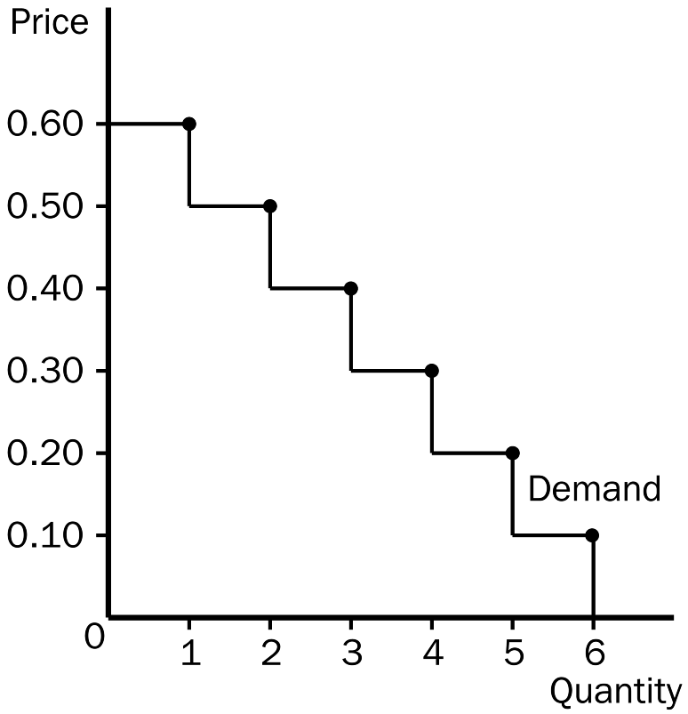
b. At a price of $0.20, Tammy would buy 5 donuts.
c. The figure below shows Tammy’s consumer surplus. At a price of $0.20, Tammy’s consumer surplus would be $1.00.
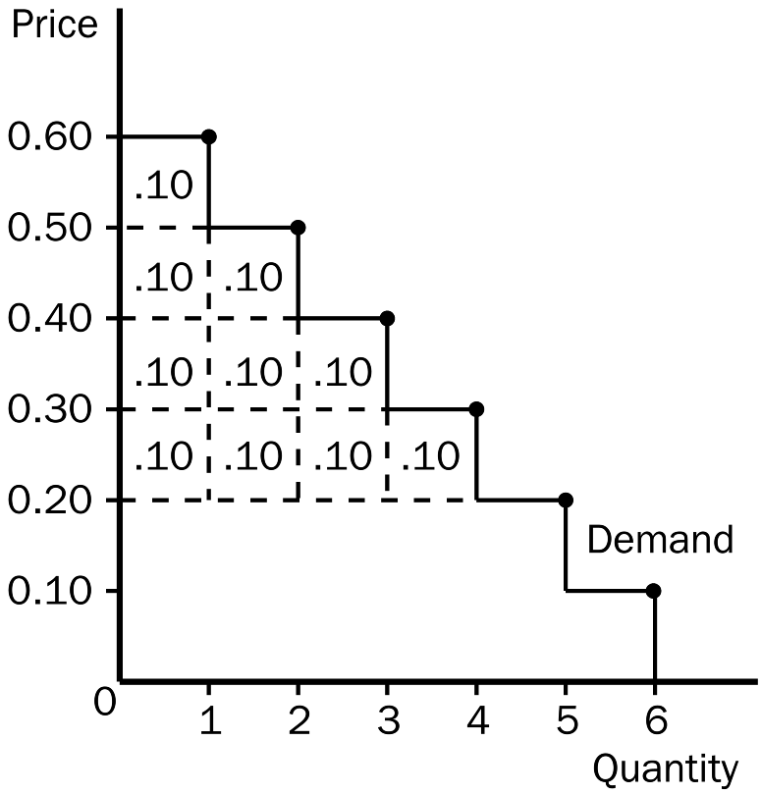

d. If the price of donuts rose to $0.40, Tammy’s consumer surplus would fall to $0.30 and she would purchase only 3 donuts.

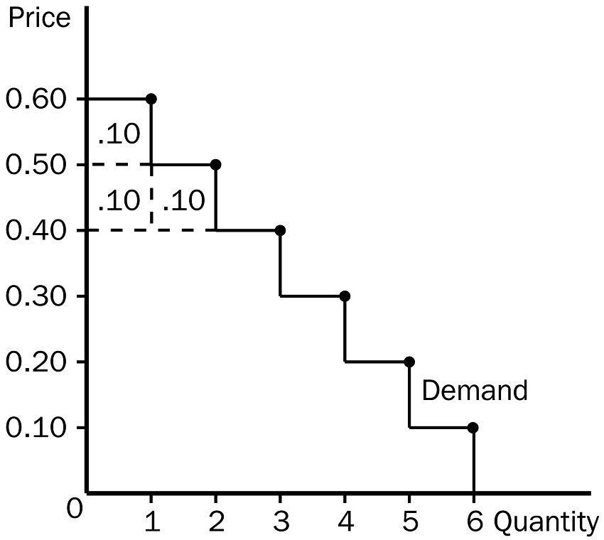
PTS: 1 DIF: 2 REF: 7-1
TOP: Demand | Consumer surplus MSC: Applicative
3. Answer each of the following questions about supply and producer surplus.
a. What is producer surplus, and how is it measured?
b. What is the relationship between the cost to sellers and the supply curve?
c. Other things equal, what happens to producer surplus when the price of a good rises? Illustrate your answer on a supply curve.
ANS:
a. Producer surplus measures the benefit to sellers of participating in a market. It is measured as the amount a seller is paid minus the cost of production. For an individual sale, producer surplus is measured as the difference between the market price and the cost of production, as shown on the supply curve. For the market, total producer surplus is measured as the area above the supply curve and below the market price, between the origin and the quantity sold.
b. Because the supply curve shows the minimum amount sellers are willing to accept for a given quantity, the supply curve represents the cost of the marginal seller.
c. When the price of a good rises, producer surplus increases for two reasons. First, those sellers who were already selling the good have an increase in producer surplus because the price they receive is higher (area A). Second, new sellers will enter the market because the price of the good is now higher than their willingness to sell (area B); hence, there is additional producer surplus generated from their sales. The graph should show that as price rises from P₁ to P₂, producer surplus increases from area C to area A + B + C.
PTS: 1 DIF: 2 REF: 7-2
TOP: Supply | Producer surplus MSC: Interpretive
4. Given the following equations two equations:
1) | Total Surplus = Consumer Surplus + Producer Surplus
2) | Total Surplus = Value to Buyers - Cost to Sellers

Show how equation (1) can be used to derive equation (2).
ANS:
Start with the equation: Total Surplus = Consumer Surplus + Producer Surplus. Then, since Consumer Surplus = Value to buyers - Amount paid by buyers, and since Producer Surplus = Amount received by sellers - Costs of sellers, then Total Surplus can be written as: Value to buyers - Amount paid by buyers + Amount received by sellers - Costs of sellers. Since the Amount paid by buyers equals the Amount received by sellers, the middle two terms cancel out and the result is:
Total Surplus = Value to buyers - Costs of sellers.
PTS: 1 DIF: 2 REF: 7-3
TOP: Total surplus MSC: Applicative
5. Answer the following questions based on the graph that represents J.R.’s demand for ribs per week of ribs at Judy’s rib shack.
a. At the equilibrium price, how many ribs would J.R. be willing to purchase?
b. How much is J.R. willing to pay for 20 ribs?
c. What is the magnitude of J.R.’s consumer surplus be at the equilibrium price?
d. At the equilibrium price, how many ribs would Judy be willing to sell?
e. How high must the price of ribs be for Judy to supply 20 ribs to the market?
f. At the equilibrium price, what is the magnitude of total surplus in the market?
g. If the price of ribs rose to $10, what would happen to J.R.’s consumer surplus?
h. If the price of ribs fell to $5, what would happen to Judy’s producer surplus?
i. Explain why the graph that is shown verifies the fact that the market equilibrium (quantity) maximizes the sum of producer and consumer surplus.
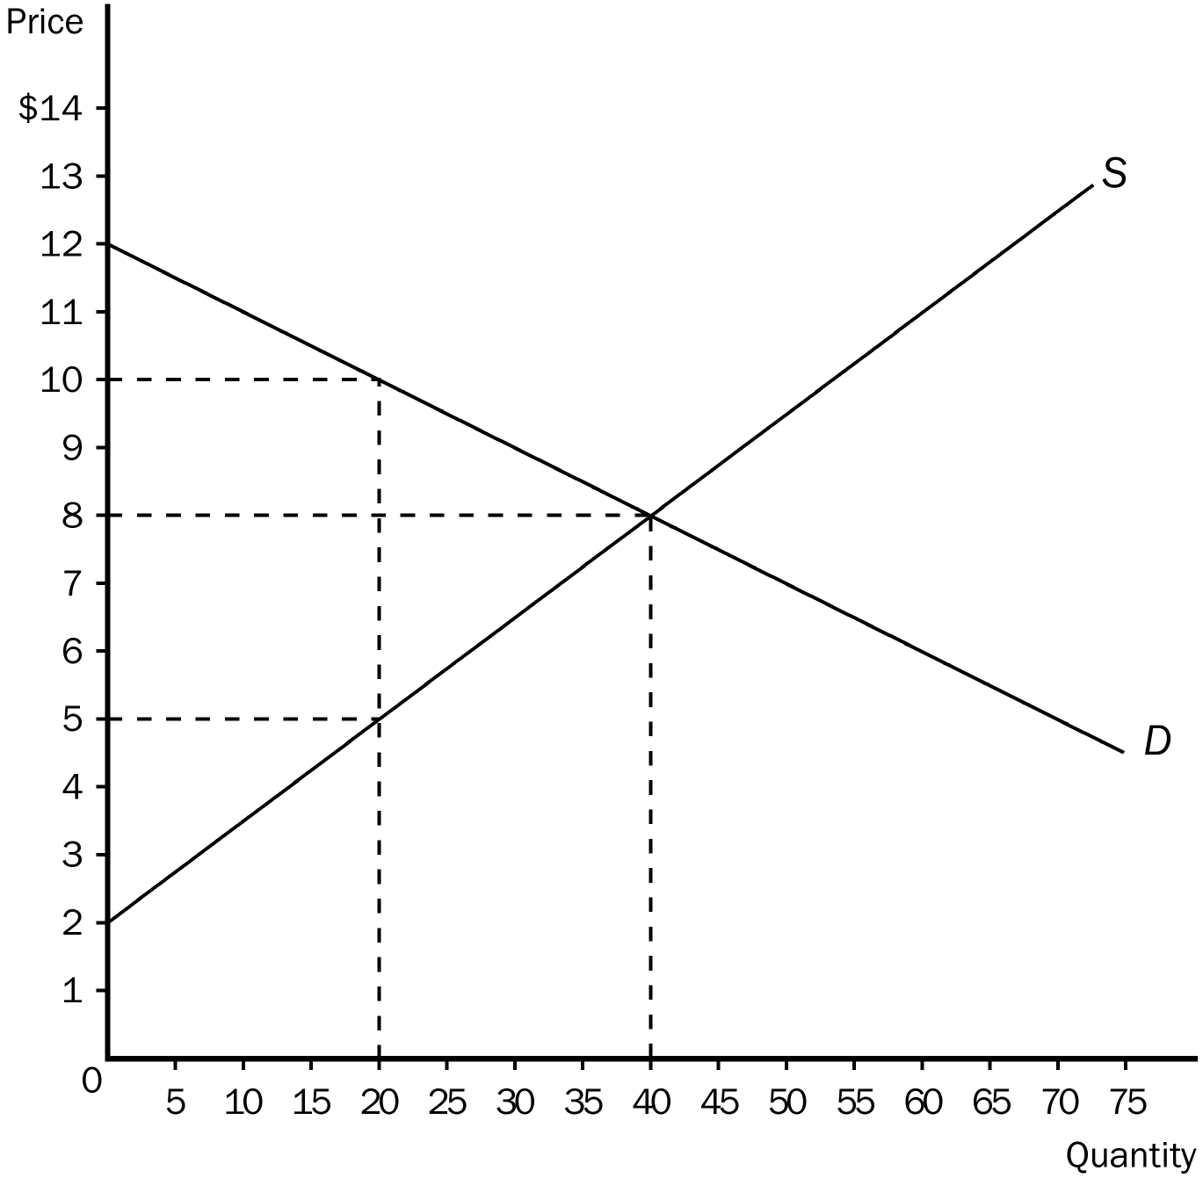
ANS:
a. 40
b. $10.00
c. $80.00.
d. 40
e. $5
f. $200
g. It would fall from $80 to only $20.
h. It would fall from $120 to only $30.
i. At quantities less than the equilibrium quantity, the value to buyers exceeds the cost to sellers. Increasing the quantity in this region raises total surplus until equilibrium quantity is reached. At quantities greater than the equilibrium quantity, the cost to sellers exceeds the value to buyers and total surplus falls.
PTS: 1 DIF: 3 REF: 7-3
TOP: Consumer surplus | Producer surplus | Total surplus MSC: Applicative

